**Movie Magic–Smart Movie Ticket Booking System**

**Project Description:**

With the increasing demand for a seamless and modern movie-watching experience, traditional ticket booking methods often fall short due to long queues, limited availability, and inconsistent service. To address this, the development team introduced Movie Magic—a smart, cloud-based movie ticket booking system. Built using Flask for backend development, hosted on AWS EC2, and integrated with DynamoDB for dynamic data management, the platform allows users to register, log in, and book movie tickets online with ease. Users can search for movies and events based on location, view real-time seat availability, and complete their bookings in just a few clicks. Upon booking, AWS SNS sends instant email notifications confirming ticket details, enhancing user engagement and trust. This cloud-native solution streamlines the entire movie ticketing process, ensuring fast, scalable, and user-friendly access to entertainment for all.

## Scenarios :

**Scenario 1:** Efficient Ticket Booking System for Users

In the Movie Magic System, AWS EC2 provides a reliable infrastructure capable of handling multiple users accessing the platform simultaneously. For example, a user can log in, navigate to the movie selection page, and seamlessly browse available shows and events in their city. They can then select a showtime, pick their preferred seats using an interactive layout, and confirm the booking—all in real-time. Flask manages backend processes, ensuring smooth data flow and quick response times even during high-traffic periods such as weekends or blockbuster releases.

**Scenario 2:** Seamless Booking Confirmation Notifications

When a user completes a ticket booking, the Movie Magic System leverages AWS SNS to send instant email notifications to confirm the booking. For instance, once the booking is submitted, Flask processes the transaction, and SNS sends a customized email to the user with all ticket details, including movie name, date, time, and seat numbers. This real-time notification system enhances the customer experience and reduces uncertainty, while DynamoDB securely stores the booking records for both users and admins to manage and track.

**Scenario 3:** Easy Access to Movies and Events

The Movie Magic platform offers users a seamless interface to explore currently running movies and upcoming live events. After logging in, a user can search by location or genre and instantly view listings with showtimes, ratings, and available seats. Flask dynamically fetches this data from DynamoDB, ensuring real-time updates on seat availability and event information. Meanwhile, the EC2-hosted application remains stable and responsive, even during traffic spikes, providing users with an uninterrupted and enjoyable booking experience.

**AWS ARCHITECTURE**

This AWS-based architecture powers a scalable and secure web application using Amazon EC2 for hosting the backend, with a lightweight framework like Flask handling core logic. Application data is stored in Amazon DynamoDB, ensuring fast, reliable access, while user access is managed through AWS IAM for secure authentication and control. Real-time alerts and system notifications are enabled via Amazon SNS, enhancing communication and user engagement.

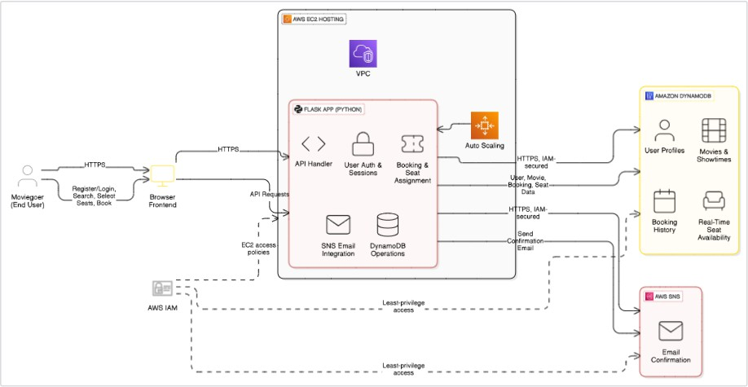

Entity Relationship (ER)Diagram:

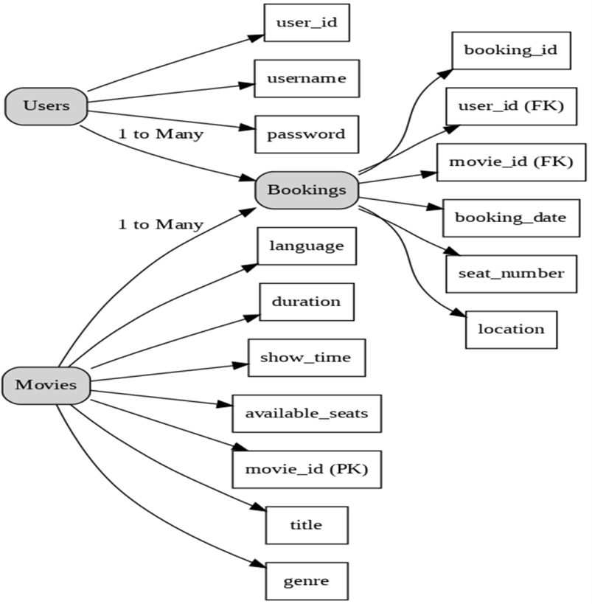

**Pre-requisites**

* **AWS Account Setup :** [**https://docs.aws.amazon.com/accounts/latest/reference/getting-started.html**](https://docs.aws.amazon.com/accounts/latest/reference/getting-started.html)
* **AWS IAM (Identity and Access Management) :** [**https://docs.aws.amazon.com/IAM/latest/UserGuide/introduction.html**](https://docs.aws.amazon.com/IAM/latest/UserGuide/introduction.html)
* **AWS EC2 (Elastic Compute Cloud) :** [**https://docs.aws.amazon.com/AWSEC2/latest/UserGuide/concepts.html**](https://docs.aws.amazon.com/AWSEC2/latest/UserGuide/concepts.html)
* **AWS DynamoDB :** [**https://docs.aws.amazon.com/amazondynamodb/latest/developerguide/Introducti**](https://docs.aws.amazon.com/amazondynamodb/latest/developerguide/Introduction.html)[**on.html**](https://docs.aws.amazon.com/amazondynamodb/latest/developerguide/Introduction.html)
* **Amazon SNS :** [**https://docs.aws.amazon.com/sns/latest/dg/welcome.htm**](https://docs.aws.amazon.com/sns/latest/dg/welcome.htm)**l**
* **Git Documentation :** [**https://git-scm.com/doc**](https://git-scm.com/doc)
* **VS Code Installation : (download the VS Code using the below link or you can get that in Microsoft store)**

[**https://code.visualstudio.com/download**](https://code.visualstudio.com/download)

**Project Flow**

**Milestone 1. Backend Development and Application Setup**

* **Develop the Backend Using Flask.**
* **Integrate AWS Services Using boto3. Milestone 2. AWS Account Setup and Login**
* **Set up an AWS account if not already done.**
* **Log in to the AWS Management Console Milestone 3. DynamoDB Database Creation and Setup**
* **Create a DynamoDB Table.**
* **Configure Attributes for User Data and Book Requests. Milestone 4. SNS Notification Setup**
* **Create SNS topics for book request notifications.**
* **Subscribe users and library staff to SNS email notifications. Milestone 5. IAM Role Setup**
* **Create IAM Role**
* **Attach Policies Milestone 6. EC2 Instance Setup**
* **Launch an EC2 instance to host the Flask application.**
* **Configure security groups for HTTP, and SSH access. Milestone 7. Deployment on EC2**
* **Upload Flask Files**
* **Run the Flask App**

**Milestone 8. Testing and Deployment**

* **Conduct functional testing to verify user registration, login, book requests, and notifications.**

Milestone 1 : Web Application Development And Setup

Backend Development and Application Setup focuses on establishing the core structure of the application. This includes configuring the backend framework, setting up routing, and integrating database connectivity. It lays the groundwork for handling user interactions, data management, and secure access.

## LOCAL DEPLOYMENT

* + File Explorer Structure

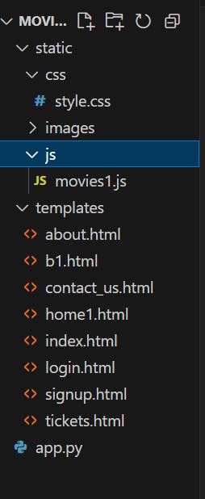

## Description of the code :

* 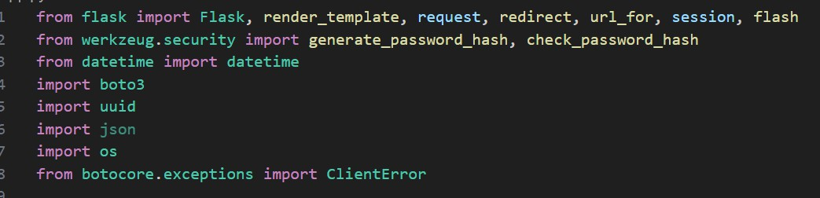**Flask App Initialization Imports and Configuration:**

**Description**: This project uses Flask for routing, session management, and user authentication with secure password hashing. It integrates AWS services via Boto3 for handling data storage, notifications, and unique user operations.

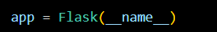

**Description:**A new Flask application instance is initialized, and a secret key is set to securely manage user sessions and protect against cookie tampering.

## Dynamodb and SNS Setup:

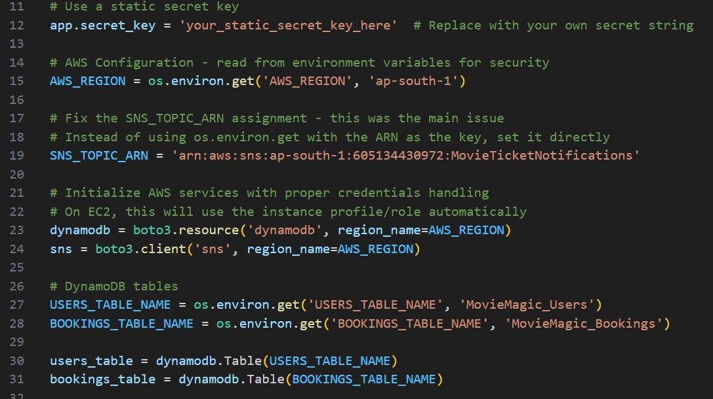

**Description**: Use **boto3** to connect to **DynamoDB** for handling user registration, movie bookings database operations and also mention region_name where Dynamodb tables are created.

## SNS Connection

* + **Description:** Configure **SNS** to send notifications when a movie ticket is booked. Paste your stored ARN link in the sns_topic_arn space, along with the region_name where the SNS topic is created. Also, specify the chosen email service in SMTP_SERVER (e.g., Gmail, Yahoo, etc.) and enter the subscribed email in the SENDER_EMAIL section. Create an ‘App password’ for the email ID and store it in the SENDER_PASSWORD section.

## Function to send the Notifications:

**Description:**This function sends a booking confirmation email using AWS SNS. It formats the booking details into a message and publishes it to a specified SNS topic, notifying the user via email about their successful movie ticket booking.

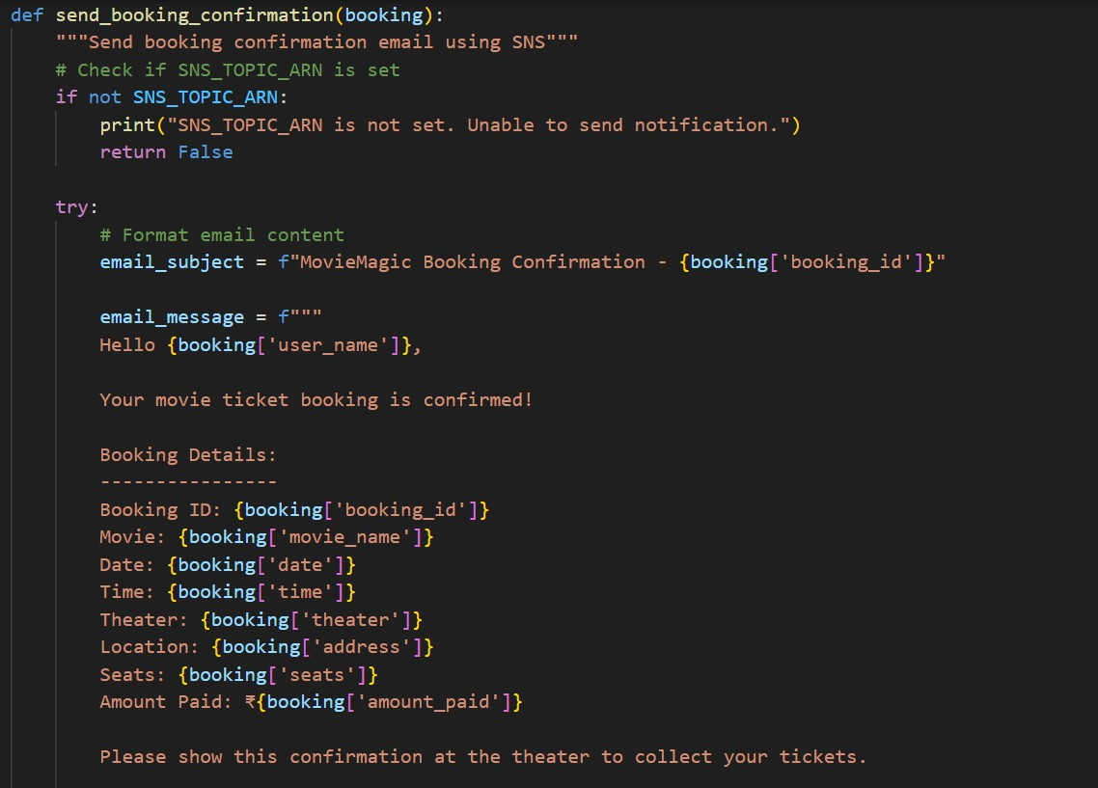



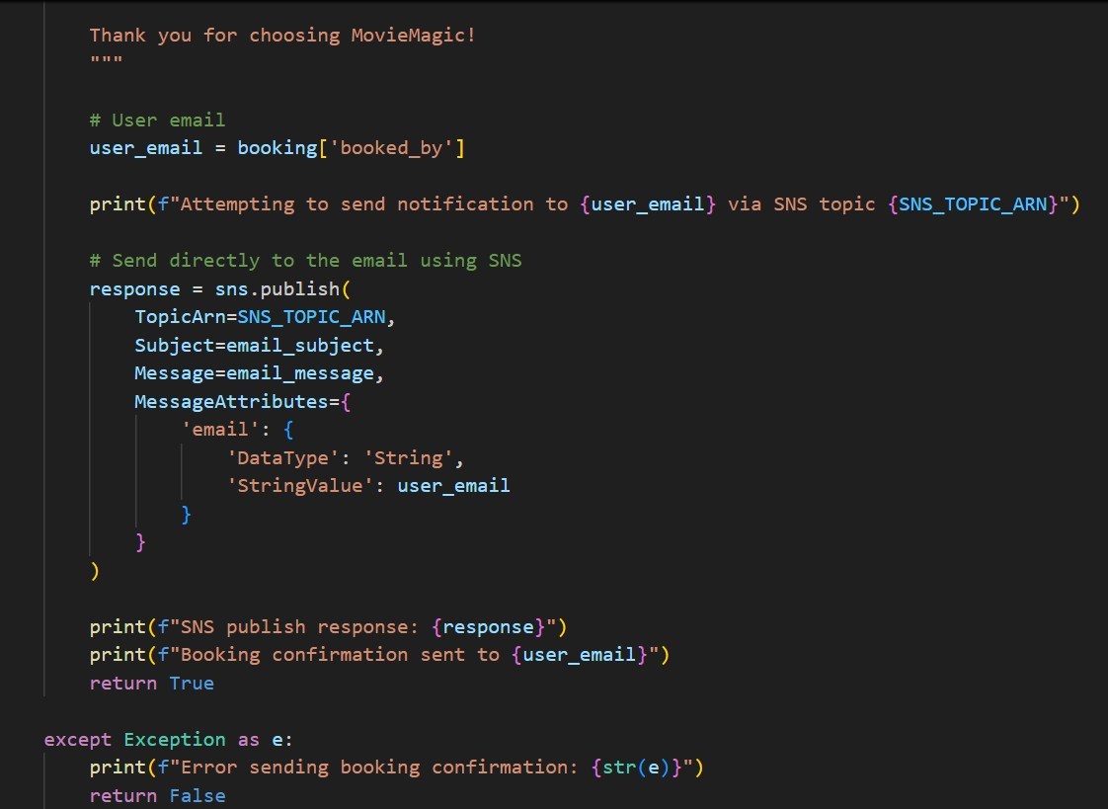

## Routes for Web Pages

* **Register User:** Collecting registration data, hashes the password, and stores user details in the database.



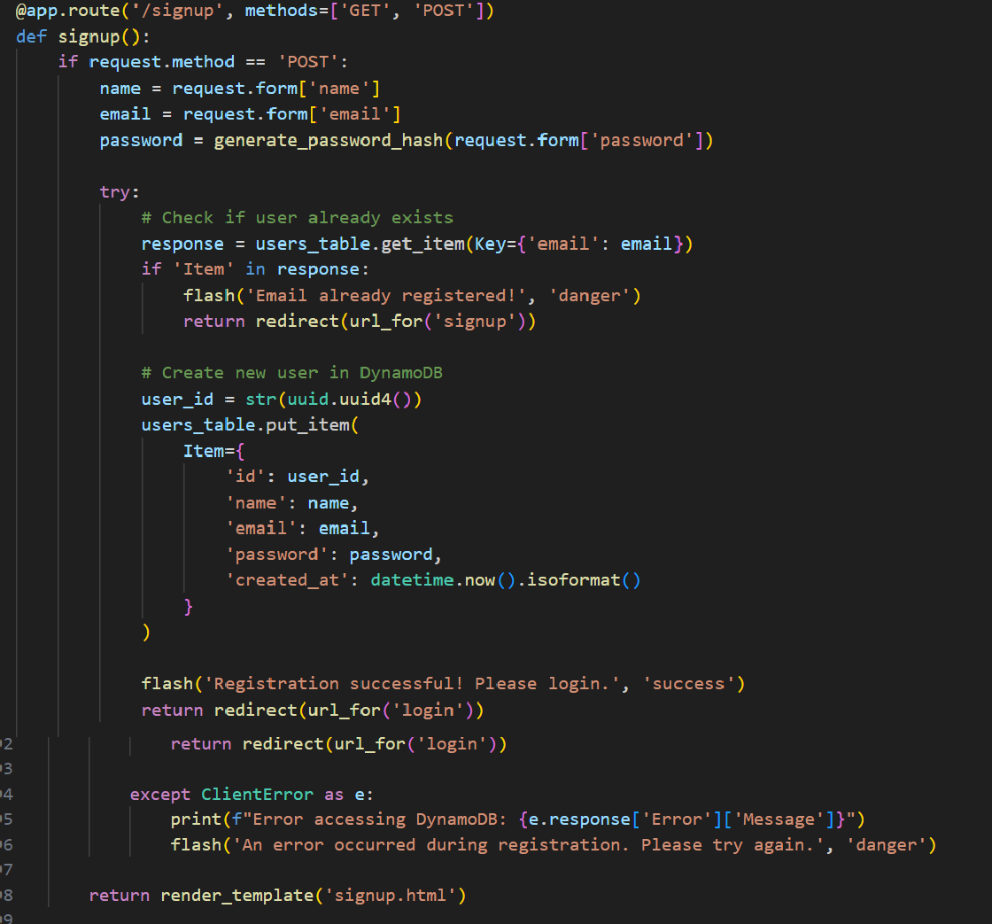

* **login Route (GET/POST)**: Verifies user credentials, increments login count, and redirects to the dashboard on success.



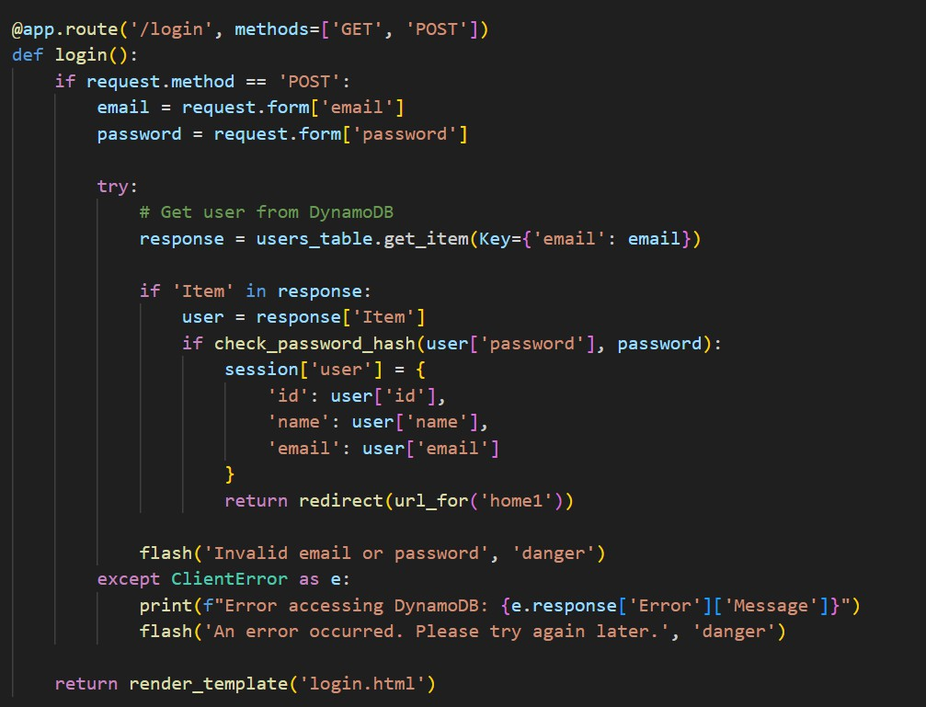

* These Flask routes handle key navigation in the app: /logout logs out the user by clearing the session and showing a flash message; /home1 is a protected route accessible only to logged-in users; /about and /contact_us render static pages with information about the app and ways to get in touch.



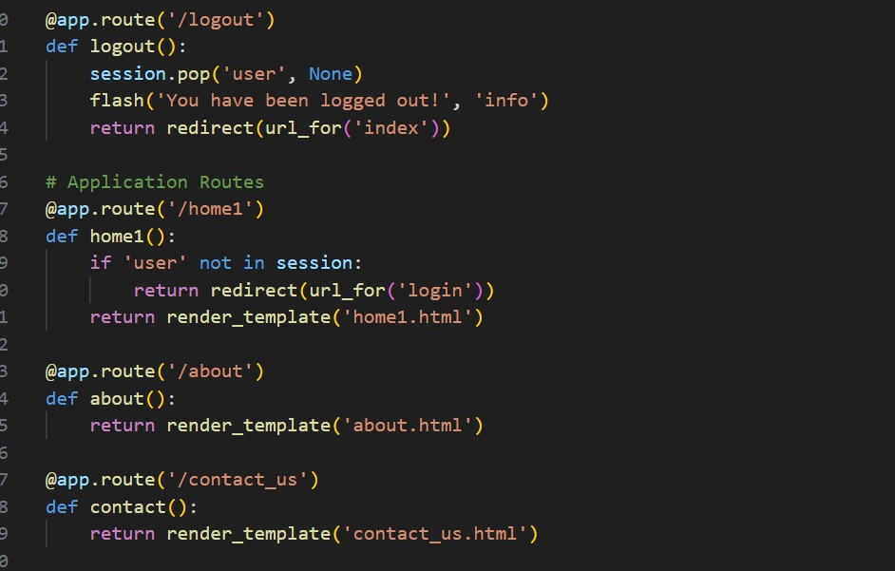

## Booking Page Route:

**Description:** This route displays the booking page (b1.html) with movie, theater, address, and price details passed as query parameters. It ensures only logged-in users can access the page.



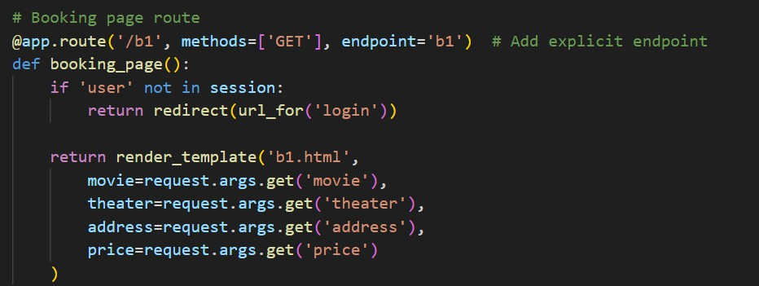

## Tickets Page Route:

**Description:** This route processes movie ticket bookings by collecting form data, generating a unique booking ID, storing details in DynamoDB, and sending a confirmation email via AWS SNS. It then displays the booking details on the tickets page.

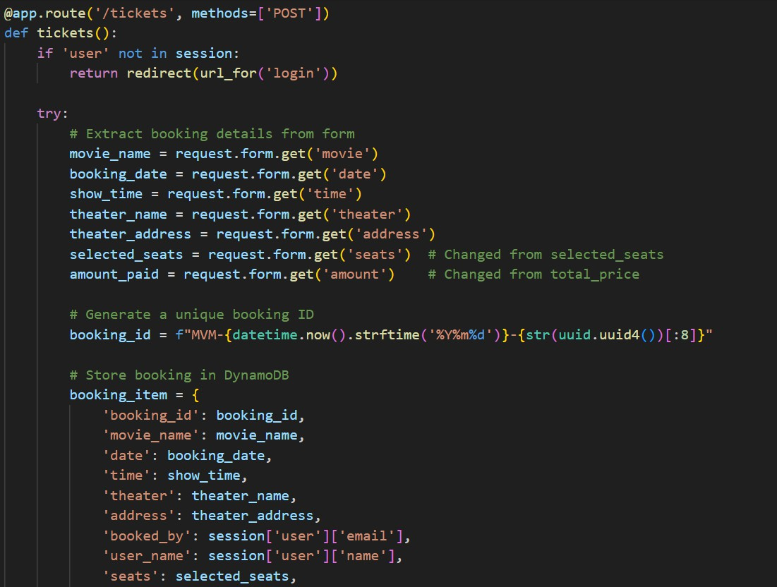



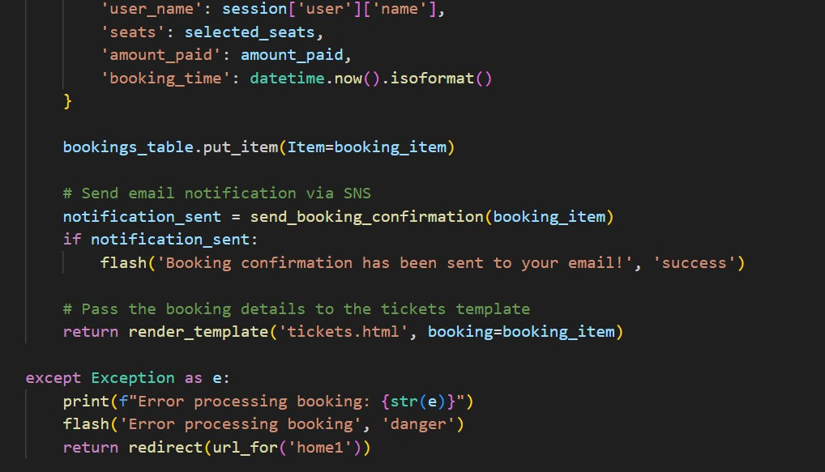

## Application Entry point:

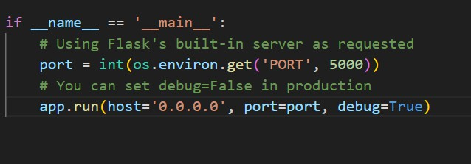

* **Description**: This block starts the Flask application using the built-in development server, setting the host, port, and enabling debug mode for easier development and testing.

○

○

○

* .

Milestone 2 : AWS Account Setup

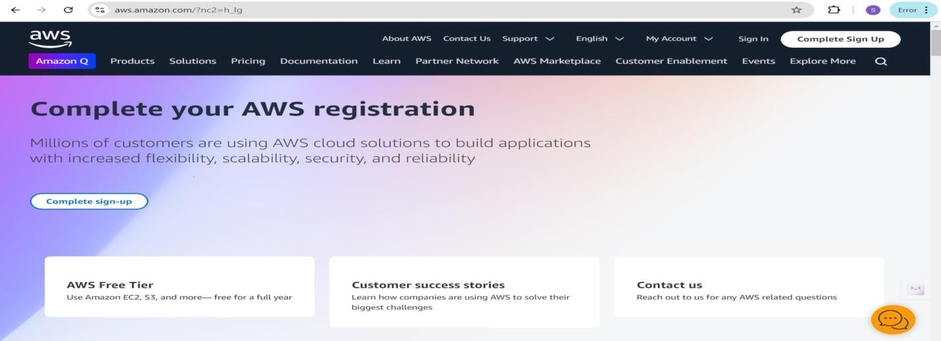

## Activity 2.2: Log in to the AWS Management Console

* + After setting up your account, log in to the [AWS Management Console.](https://aws.amazon.com/console/)

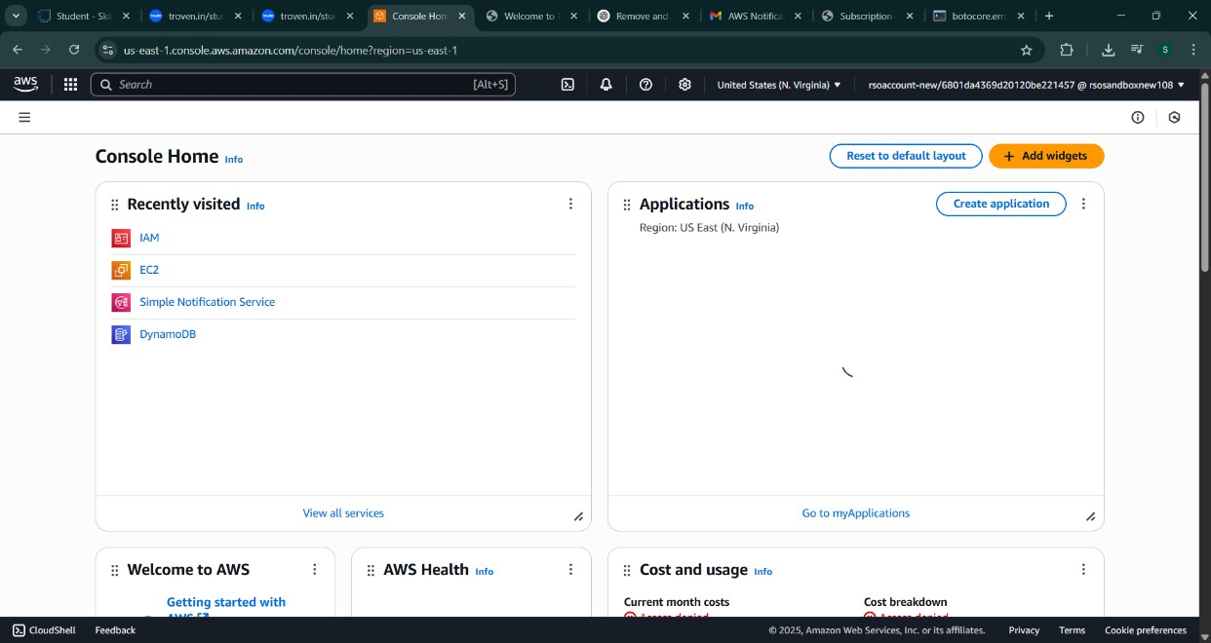

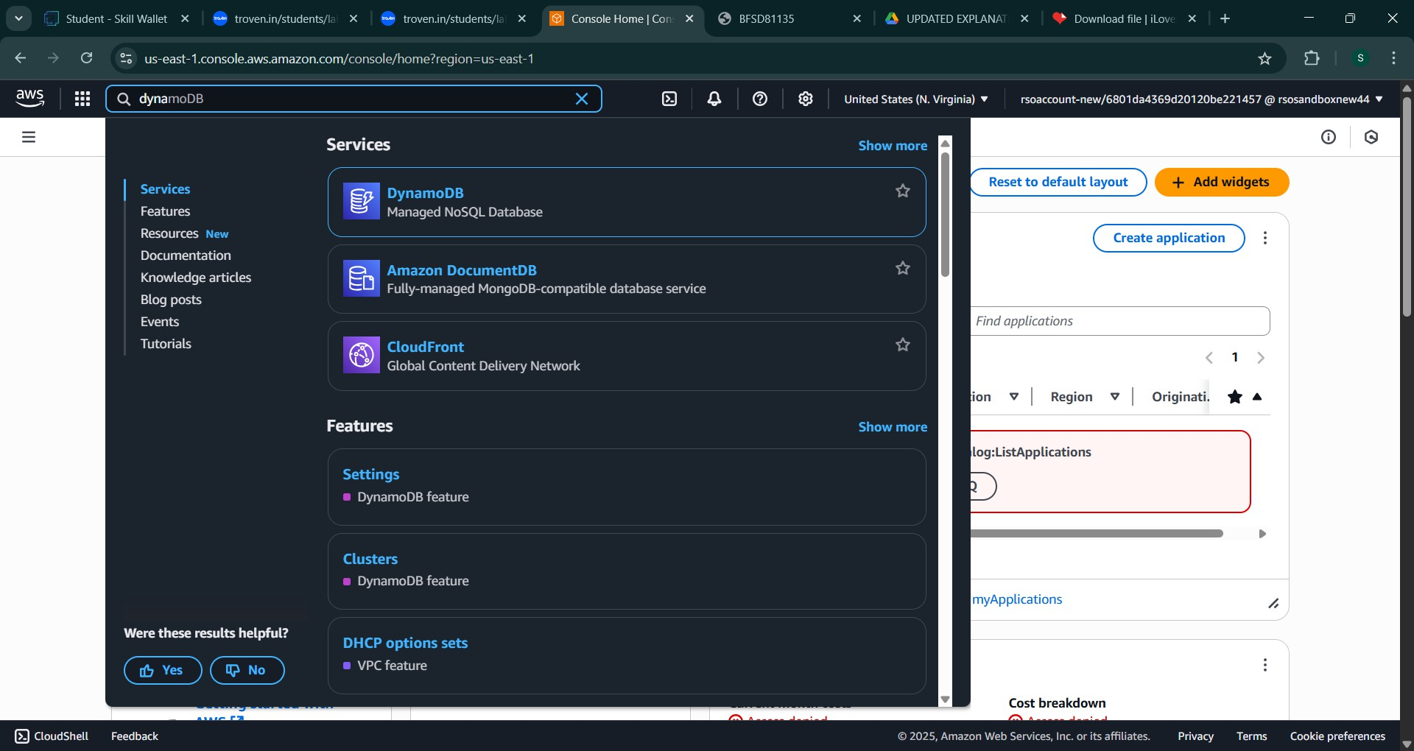

# Milestone 3: DynamoDB Database Creation and Setup

## Activity 3.1:Navigate to the DynamoDB

* + In the AWS Console, navigate to DynamoDB and click on create tables.

## 2.

**3.**

○

## Activity 3.2:Create a DynamoDB table for storing registration details and book requests.

* + Create Users table with partition key “user_email” with type String and click on create tables.

## 4.

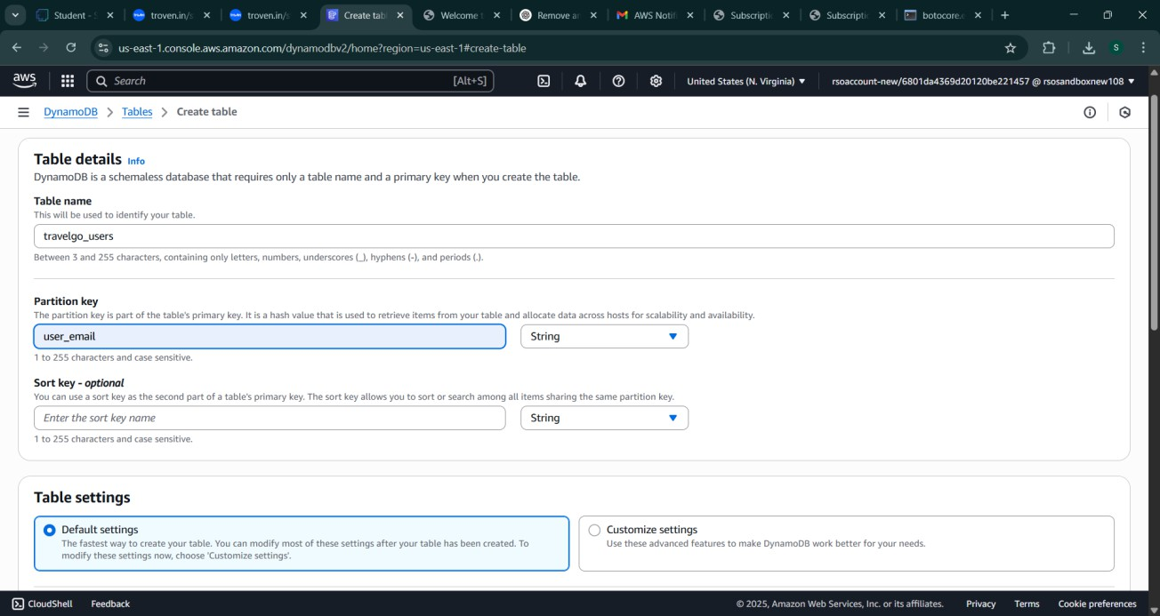

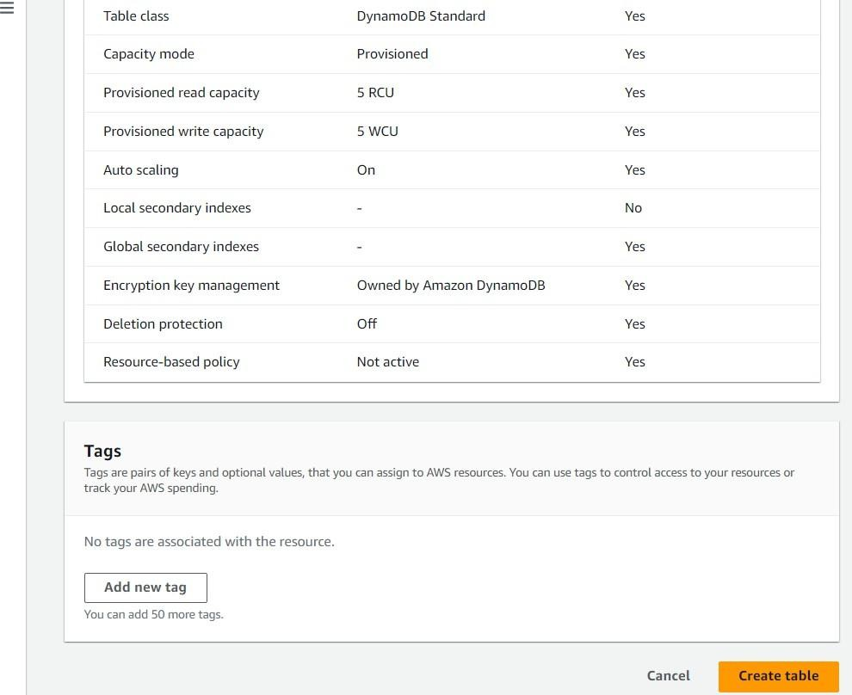

* + Follow the same steps to create a requests table with user_email as the primary key for book requests data.

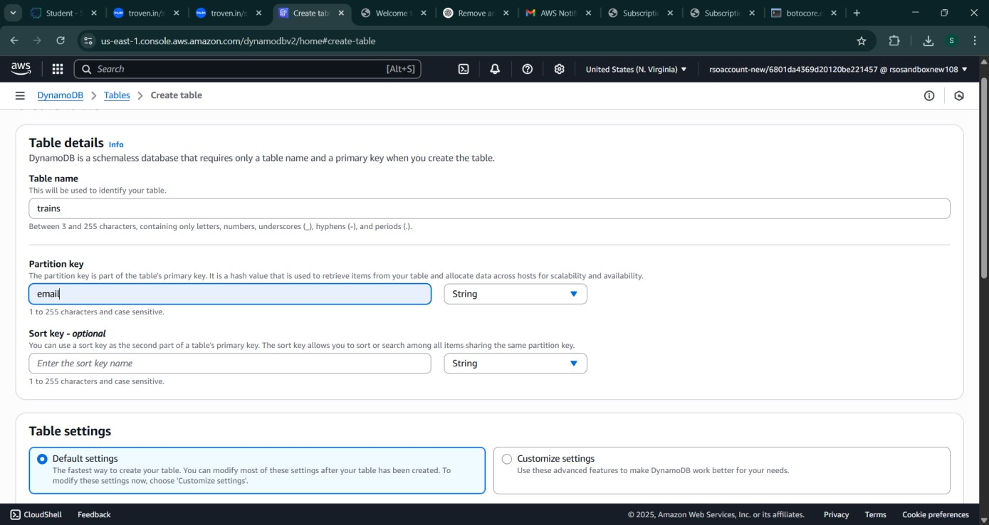

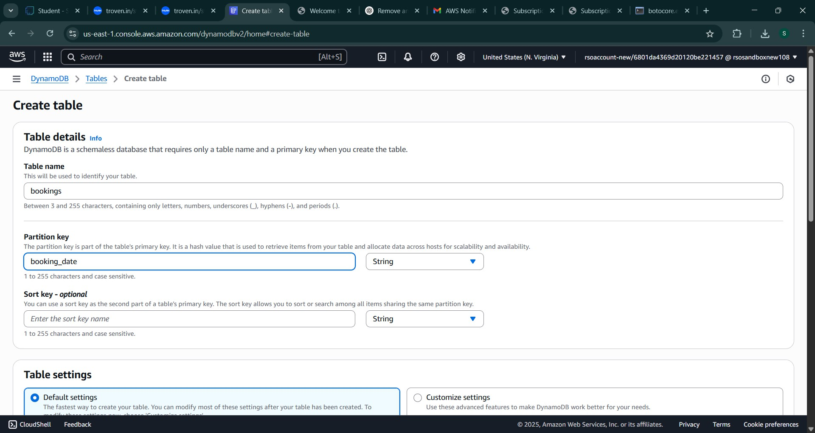

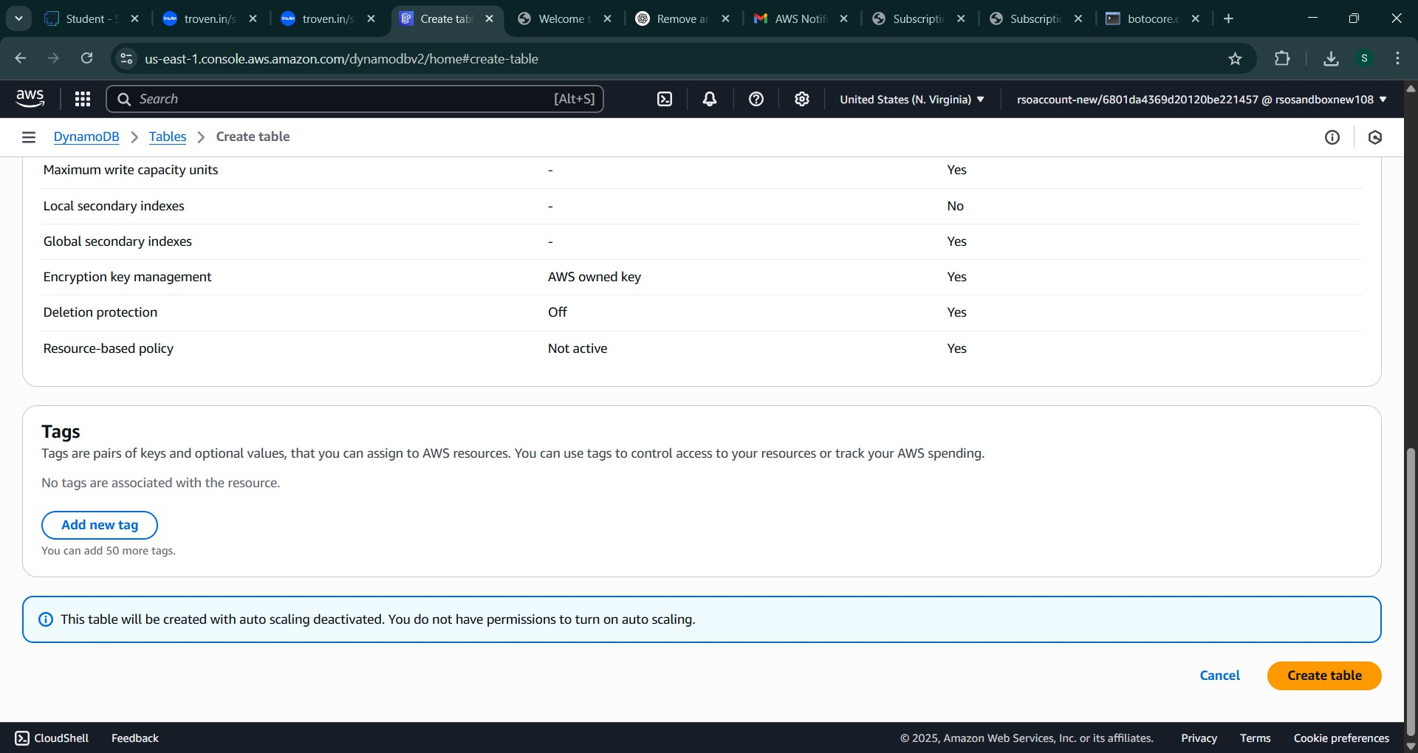

**Milestone 4: SNS Notification Setup**

## Activity 4.1: Create SNS topics for sending email notifications to users

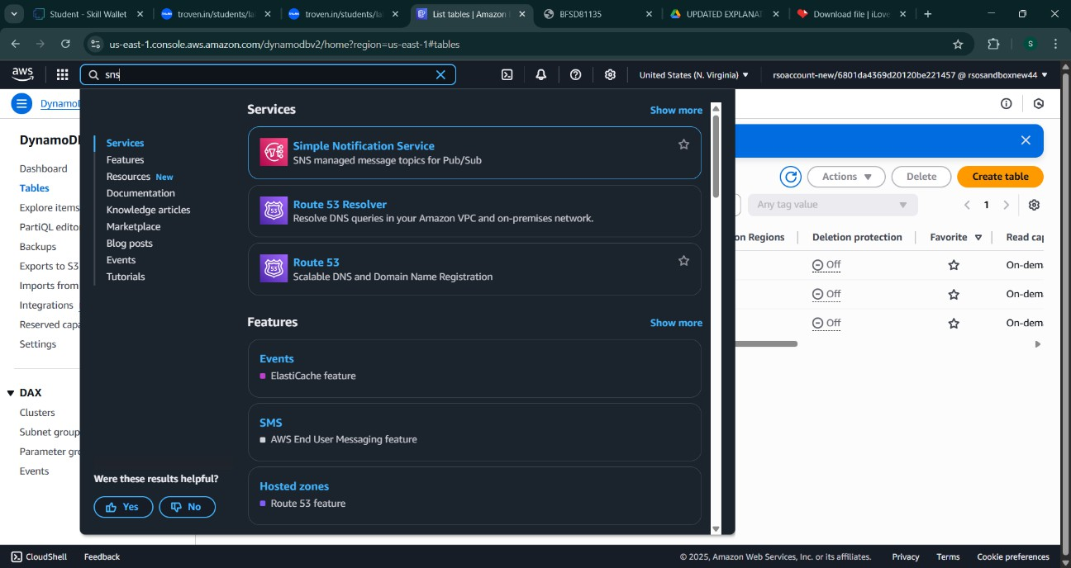

* + In the AWS Console, search for SNS and navigate to the SNS Dashboard.
* ​
* 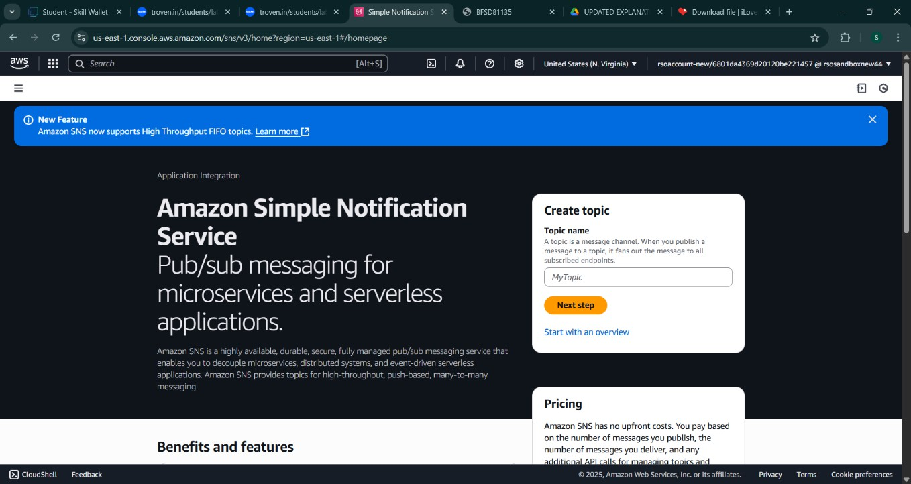
  + Click on **Create Topic** and choose a name for the topic.

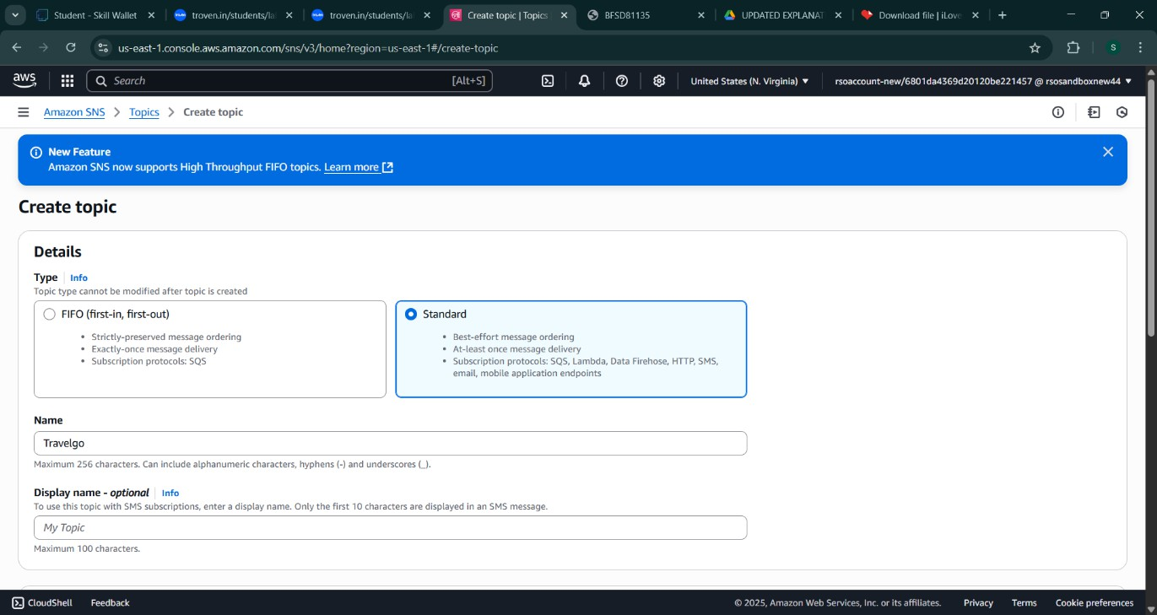

* + Choose Standard type for general notification use cases and Click on Create Topic.

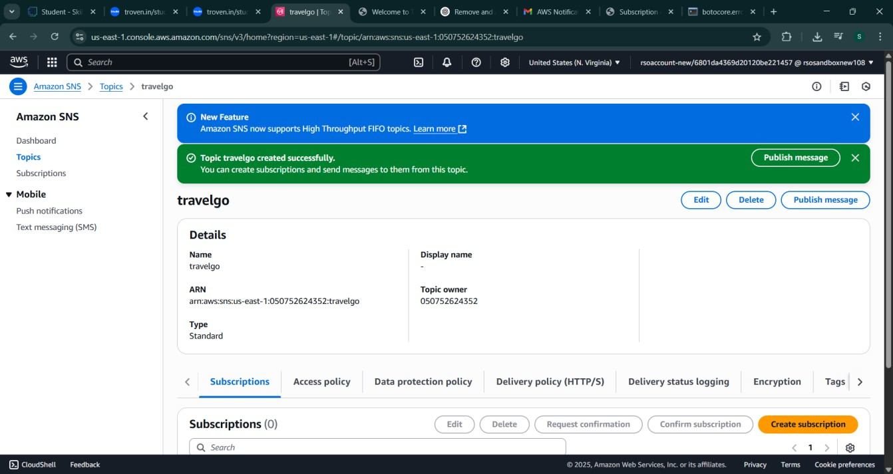

* + Configure the SNS topic and note down the **Topic ARN**.

## Activity 4.2: Subscribe users relevant SNS topics to receive real-time notifications when a book request is made.

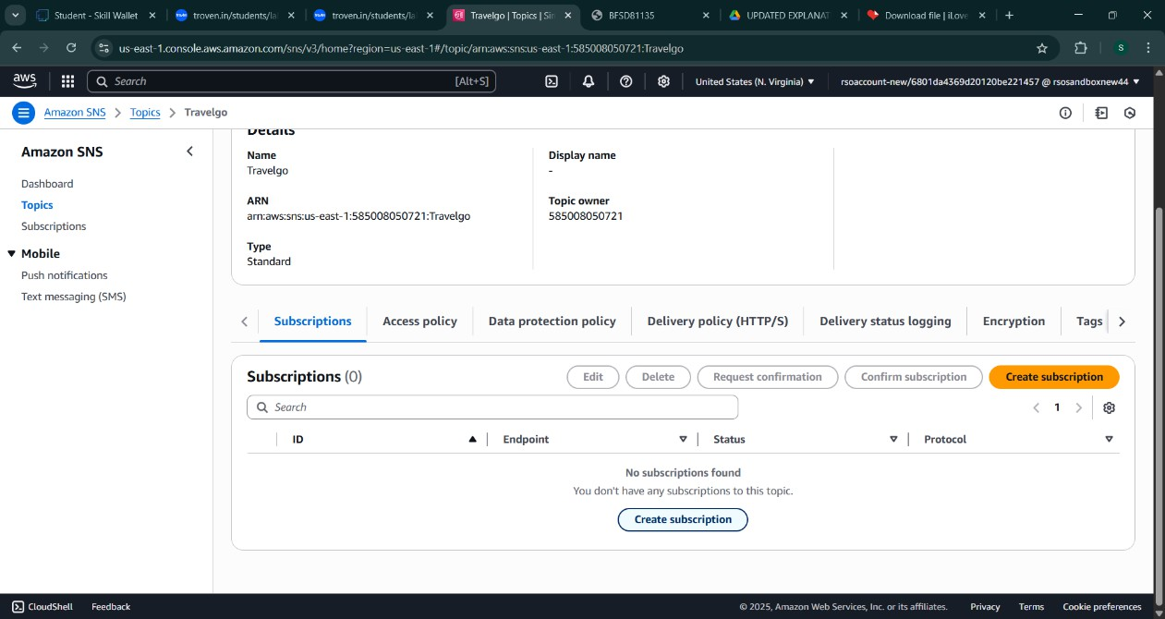

* + Subscribe users to this topic via Email. When a book request is made, notifications will be sent to the subscribed emails**.**

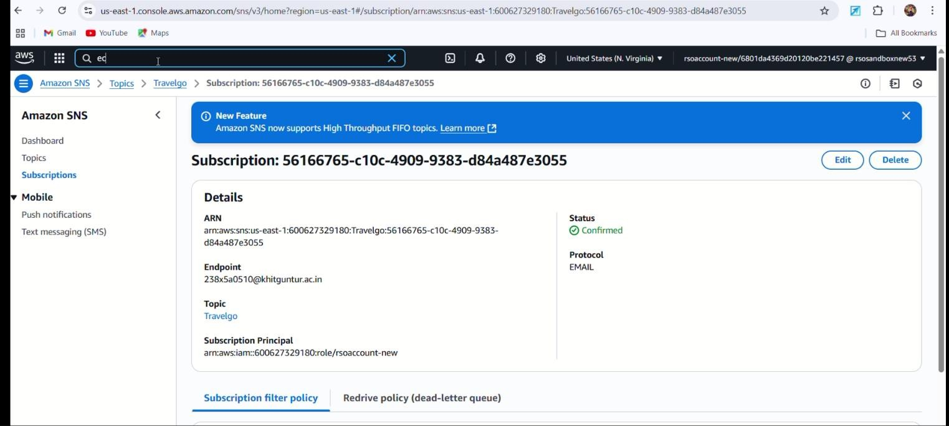

After subscription request for the mail confirmation

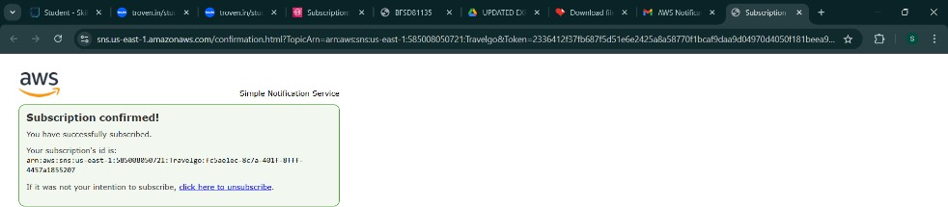

Successfully done with the SNS mail subscription and setup, now store the ARN link

.

# Milestone 5: IAM Role Setup

## Activity 5.1:Create IAM Role.

* + In the AWS Console, go to IAM and create a new IAM Role for EC2 to interact with DynamoDB and SNS.
* ​

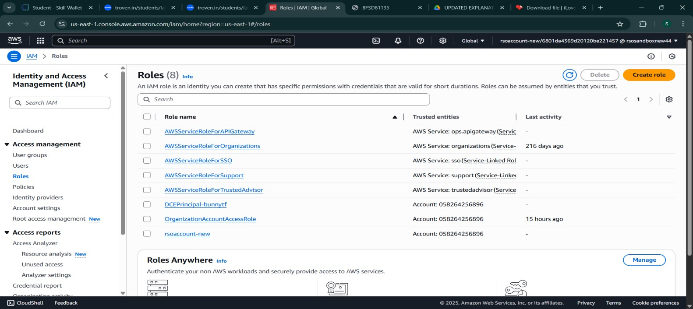

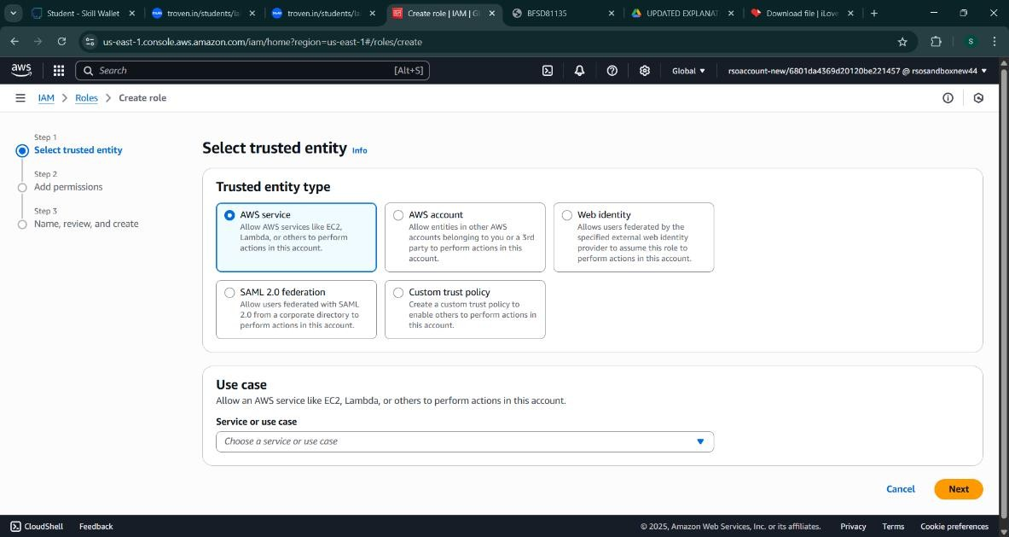

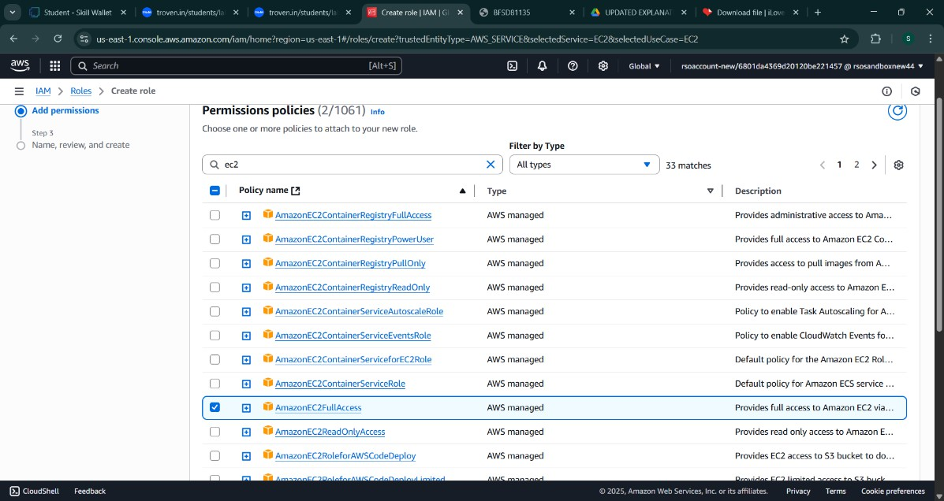

## Activity 5.2: Attach Policies.

Attach the following policies to the role:

* AmazonDynamoDBFullAccess: Allows EC2 to perform read/write operations on DynamoDB.
* AmazonSNSFullAccess: Grants EC2 the ability to send notifications via SNS.

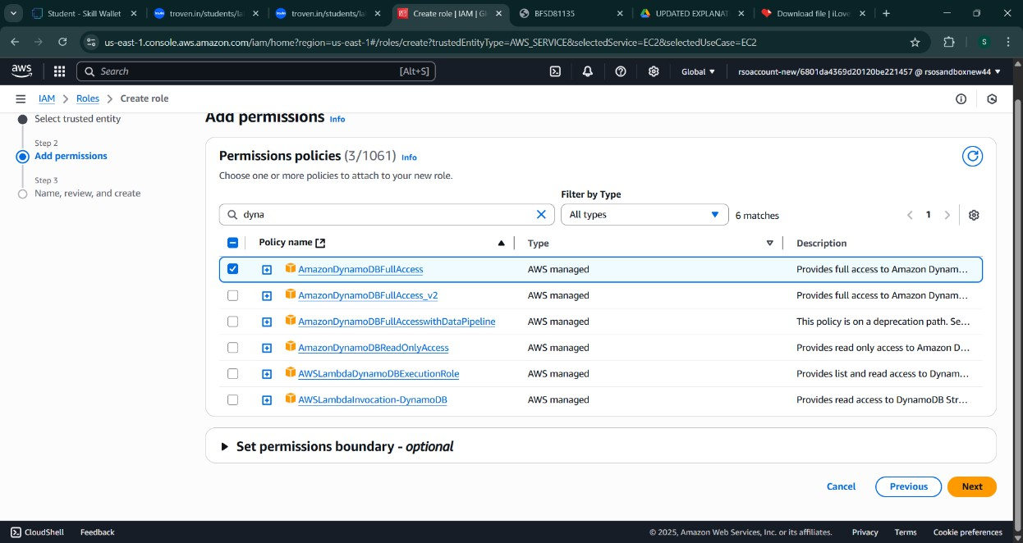

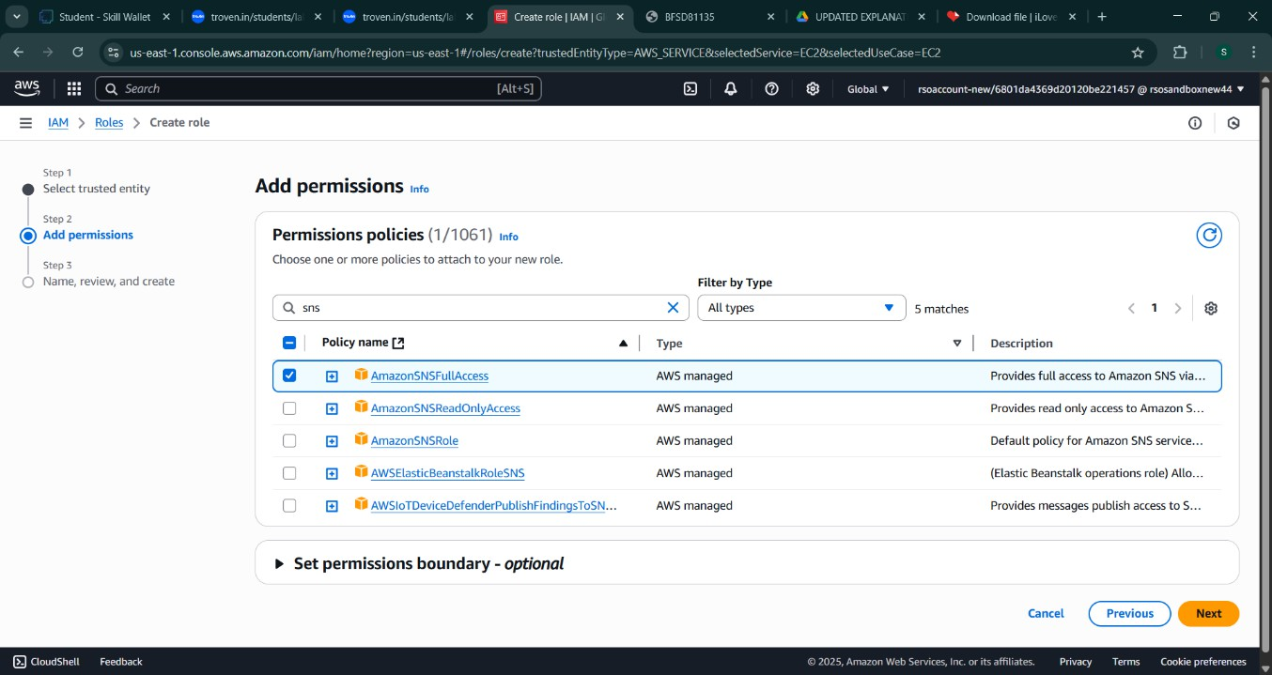

# Milestone 6: EC2 Instance Setup

* **Note: Load your Flask app and Html files into GitHub repository.**

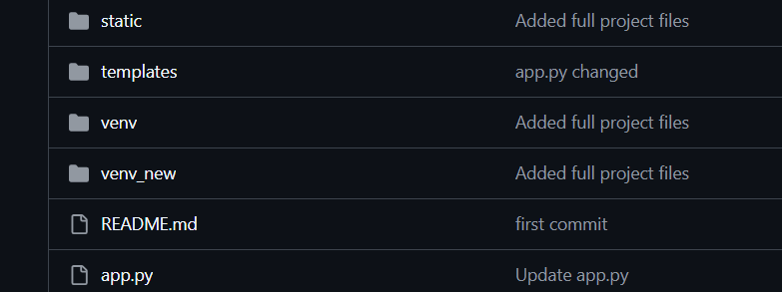

## Activity 6.1: Launch an EC2 instance to host the Flask application.

* + **Launch EC2 Instance**
    - In the AWS Console, navigate to EC2 and launch a new instance.

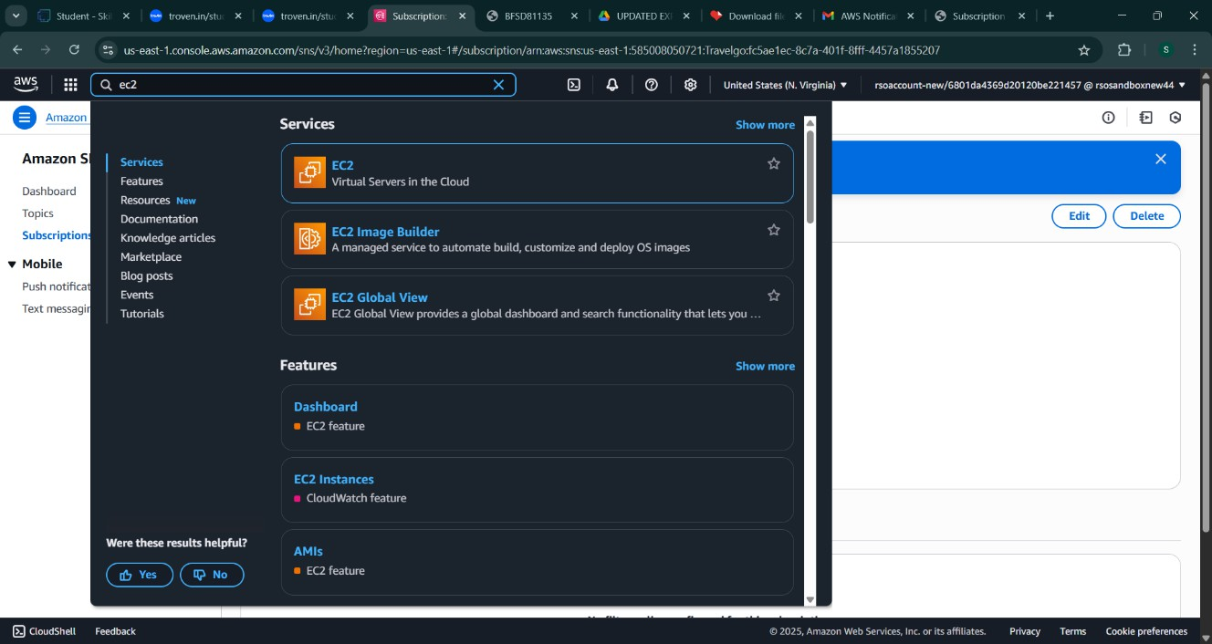

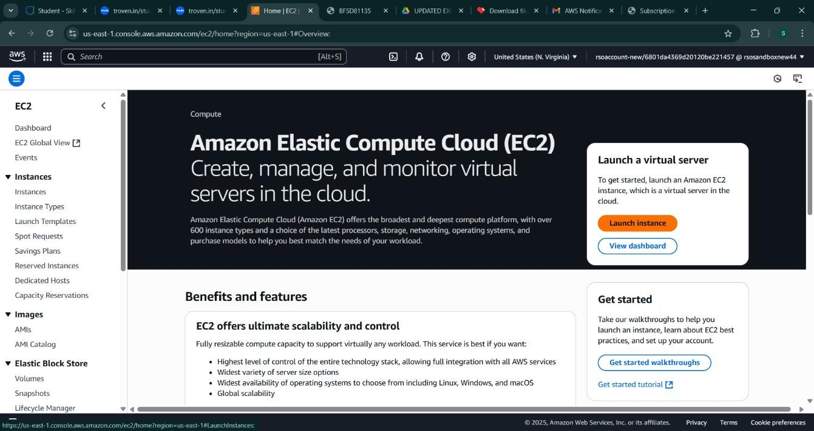

* Click on Launch instance to launch EC2 instance
  + Choose Amazon Linux 2 or Ubuntu as the AMI and t2.micro as the instance type (free-tier eligible).

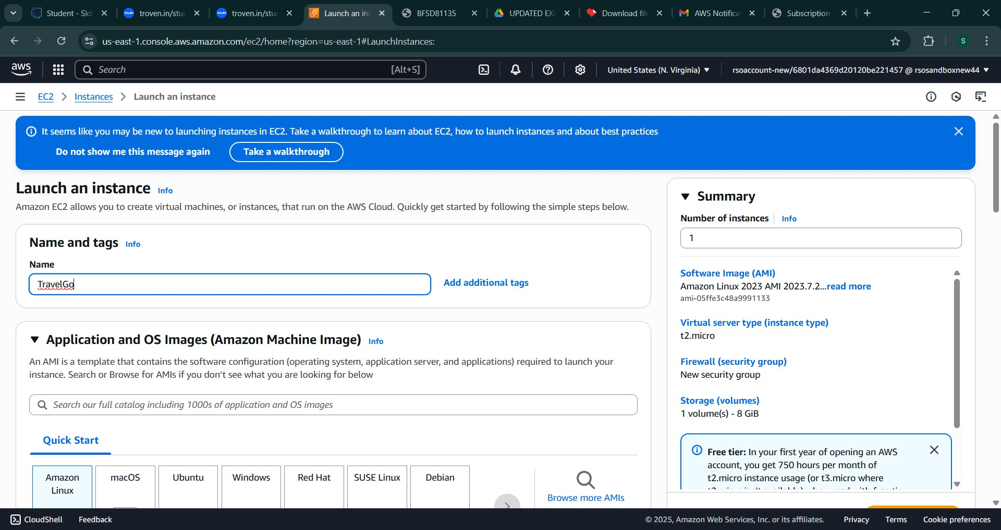

* Create and download the key pair for Server access.



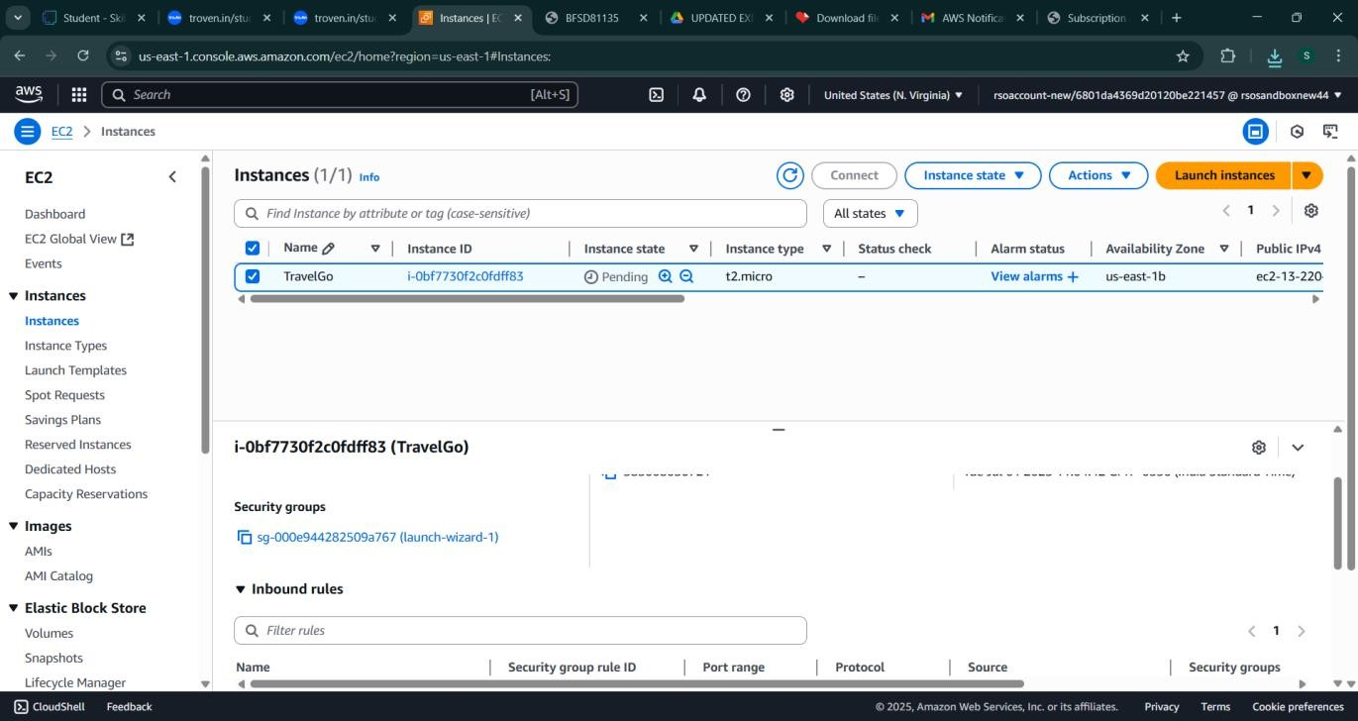

## Activity 6.2:Configure security groups for HTTP, and SSH access.

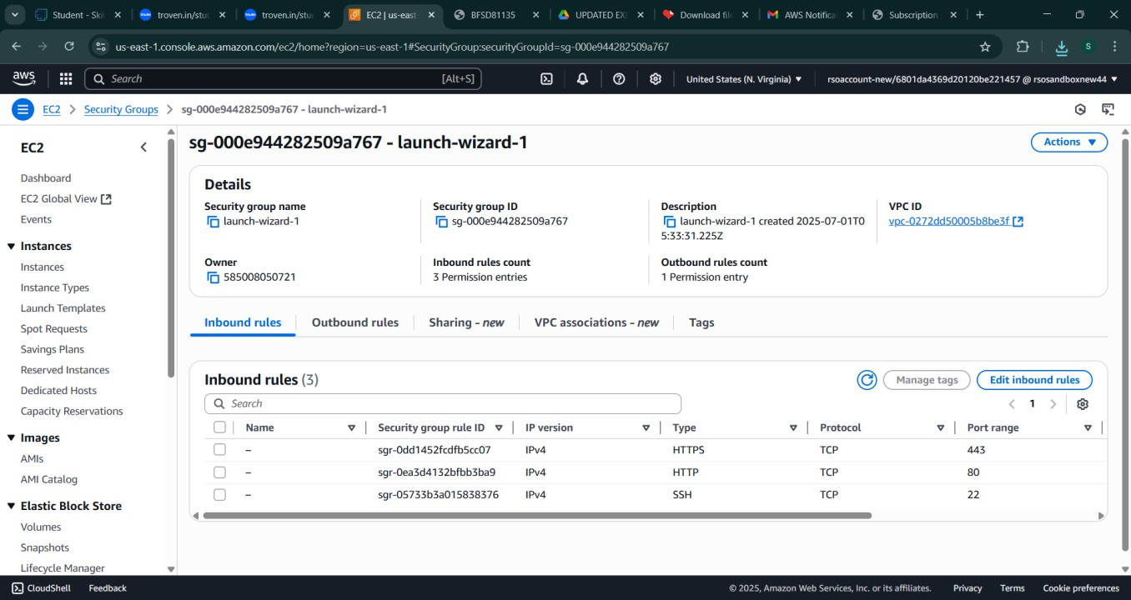

* **Activity 6.2:Configure security groups for HTTP, and SSH access.**

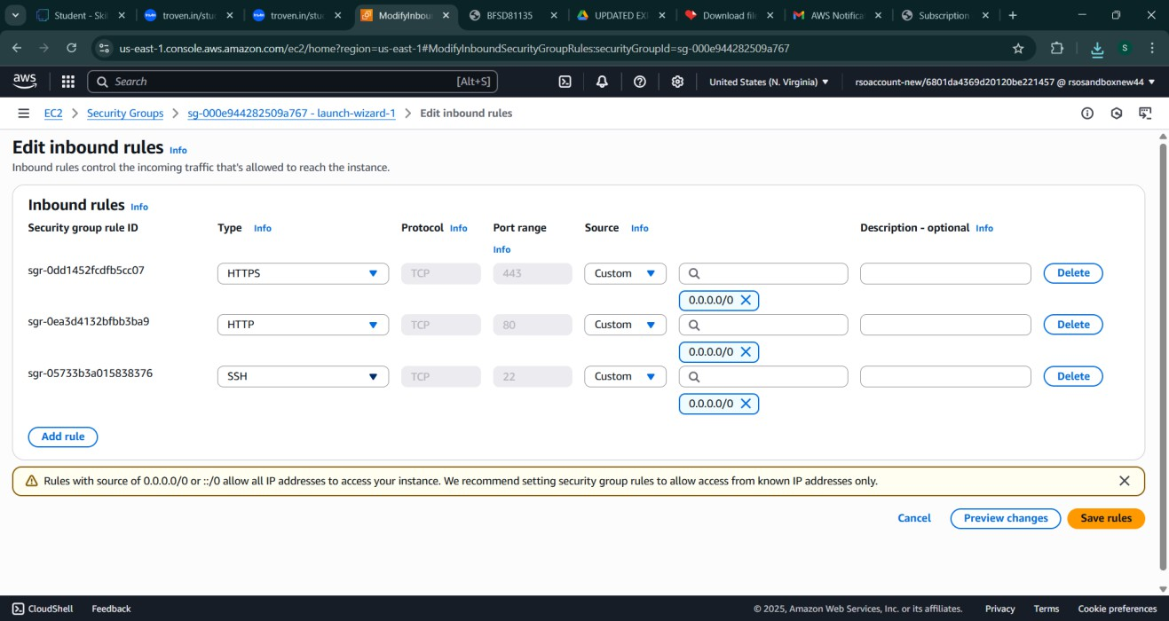

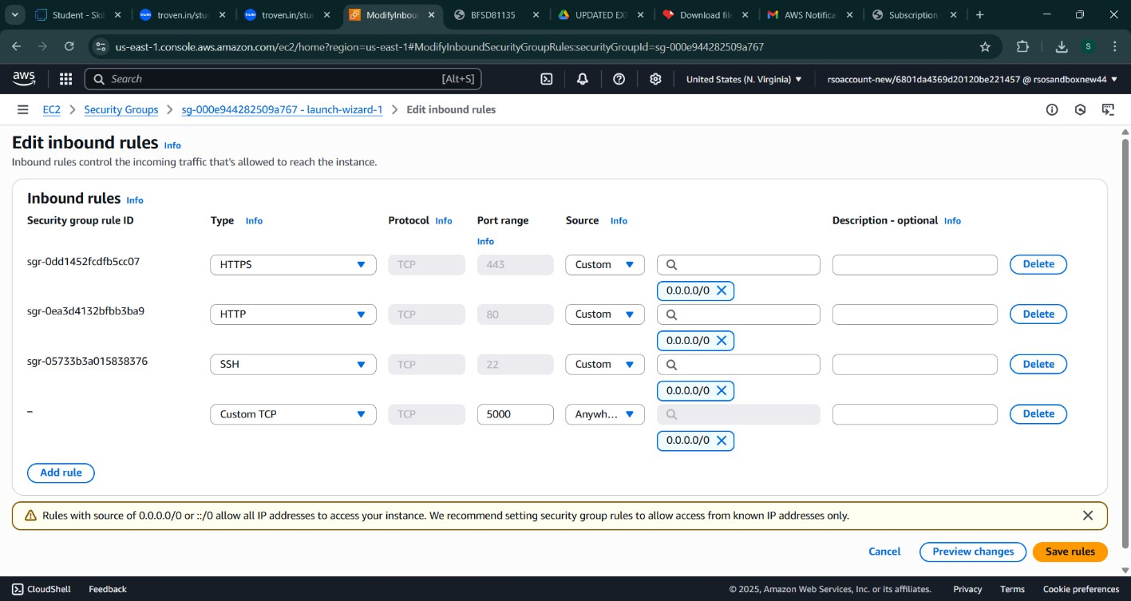

* To connect to EC2 using **EC2 Instance Connect**, start by ensuring that an **IAM role** is attached to your EC2 instance. You can do this by selecting your instance, clicking on **Actions**, then navigating to **Security** and selecting **Modify IAM Role** to attach the appropriate role. After the IAM role is connected, navigate to the **EC2** section in the **AWS Management Console**. Select the **EC2 instance** you wish to connect to. At the top of the **EC2 Dashboard**, click the **Connect** button. From the connection methods presented, choose **EC2 Instance Connect**. Finally, click **Connect** again, and a new browser-based terminal will open, allowing you to access your EC2 instance directly from your browser.

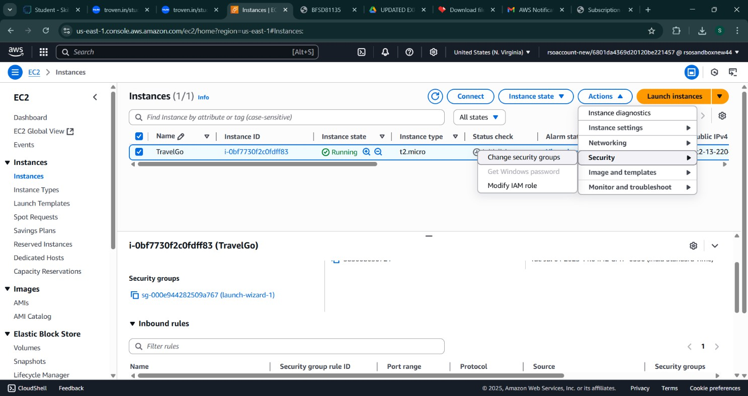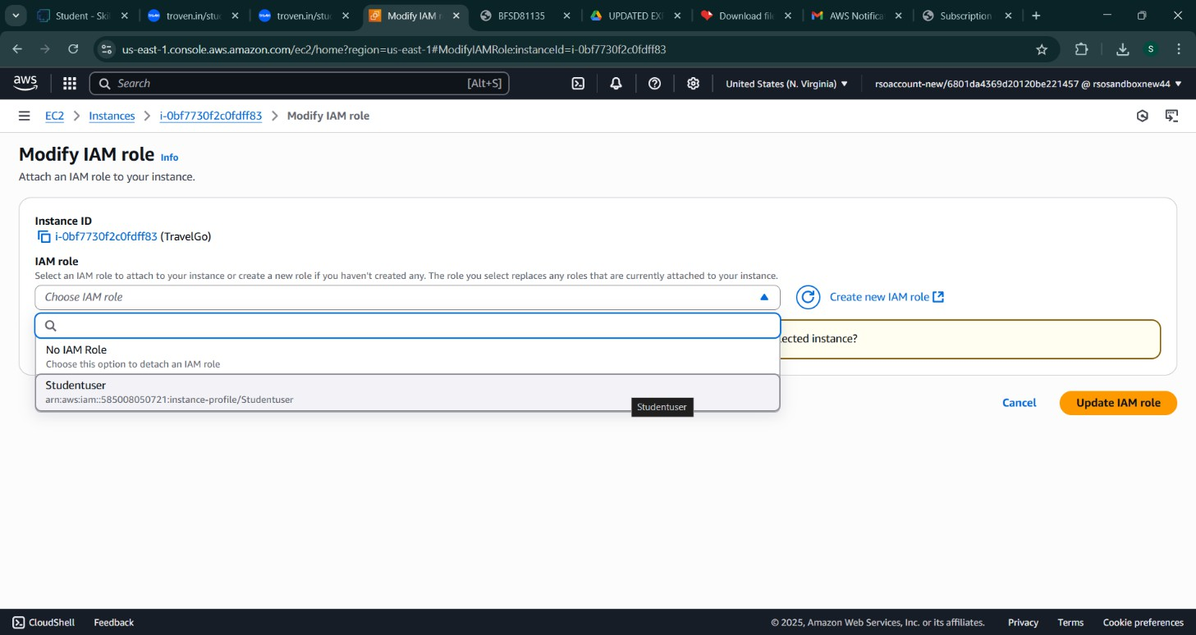

* Now connect the EC2 with the files

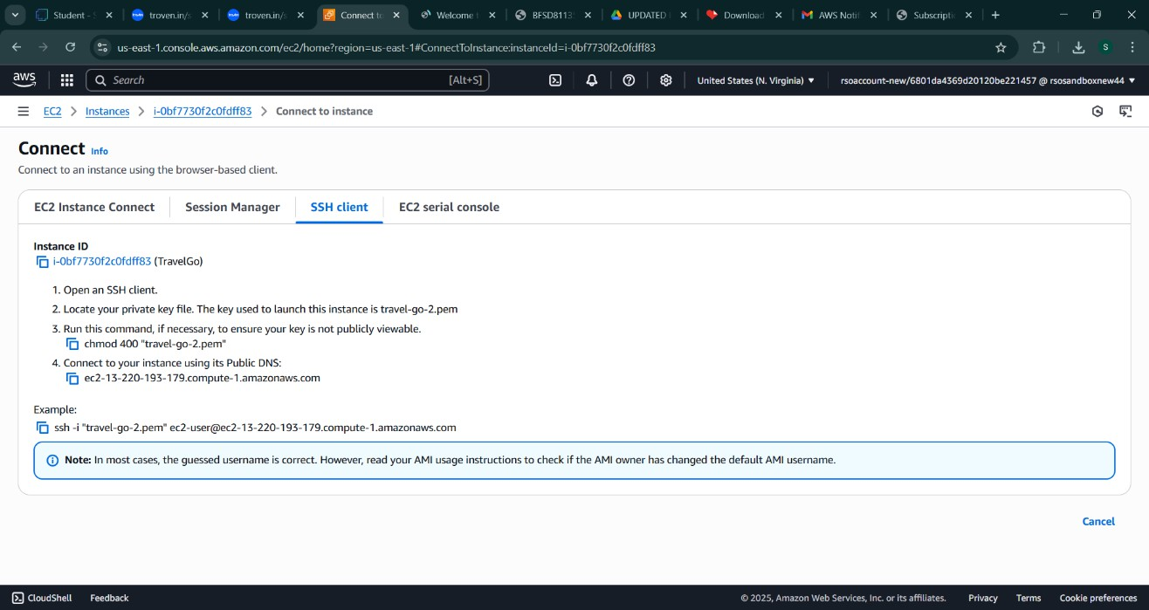

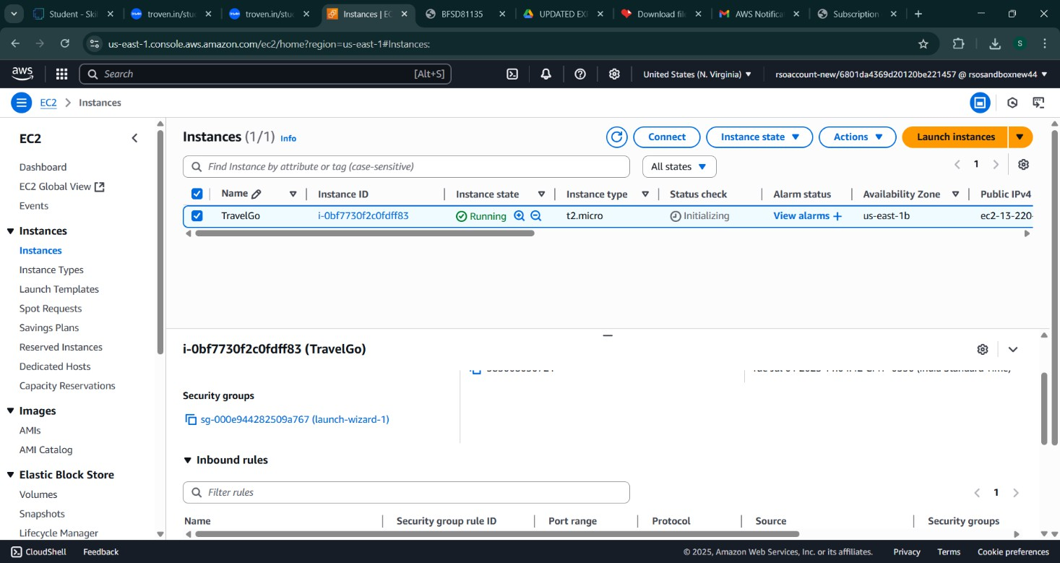

**Milestone 7: Deployment on EC2**

## Activity 7.1: Install Software on the EC2 Instance

Install Python3, Flask, and Git: On Amazon Linux 2:

sudo yum update -y

sudo yum install python3 git sudo pip3 install flask boto3

Verify Installations:

flask --version git --version

## Activity 7.2:Clone Your Flask Project from GitHub

**Clone your project repository from GitHub into the EC2 instance using Git.**

Run: ‘git clone [https://github.com/your-github-username/your-repository-name.git’](https://github.com/your-github-username/your-repository-name.git)

Note: change your-github-username and your-repository-name with your credentials

here: ‘git clone https://github.com/AlekhyaPenubakula/InstantLibrary.git’

* This will download your project to the EC2 instance.

## To navigate to the project directory, run the following command:

cd InstantLibrary

## Once inside the project directory, configure and run the Flask application by executing the following command with elevated privileges:

**Run the Flask Application**

sudo flask run --host=0.0.0.0 --port=80

**Verify the Flask app is running**: [http://your-ec2-public-ip](http://your-ec2-public-ip/)

* Run the Flask app on the EC2 instance

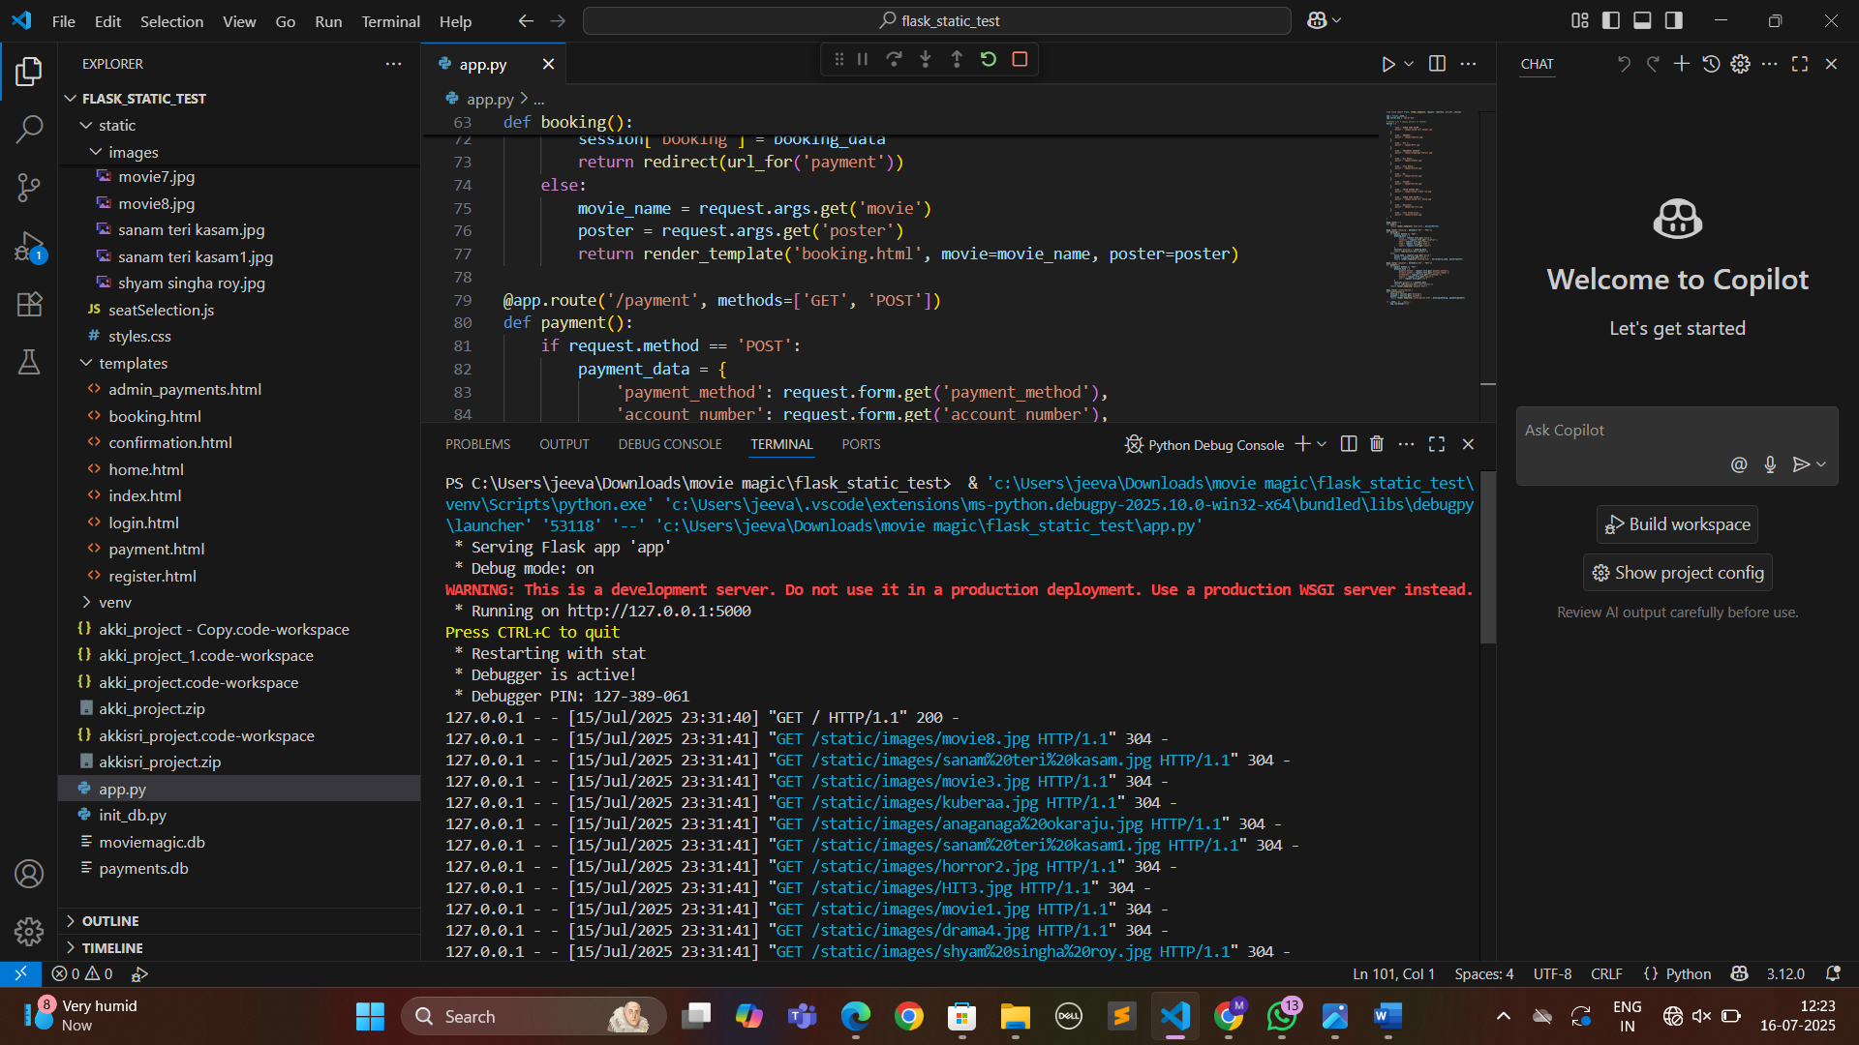

**Milestone 8: Testing and Deployment**

## Activity 8.1: Conduct functional testing to verify user registration, login, book requests, and notifications.

**Welcome Page: Register Page:**

**Login Page:**

**Home page:**

**Booking page:**

**Payment page:**

**Confirm page:**

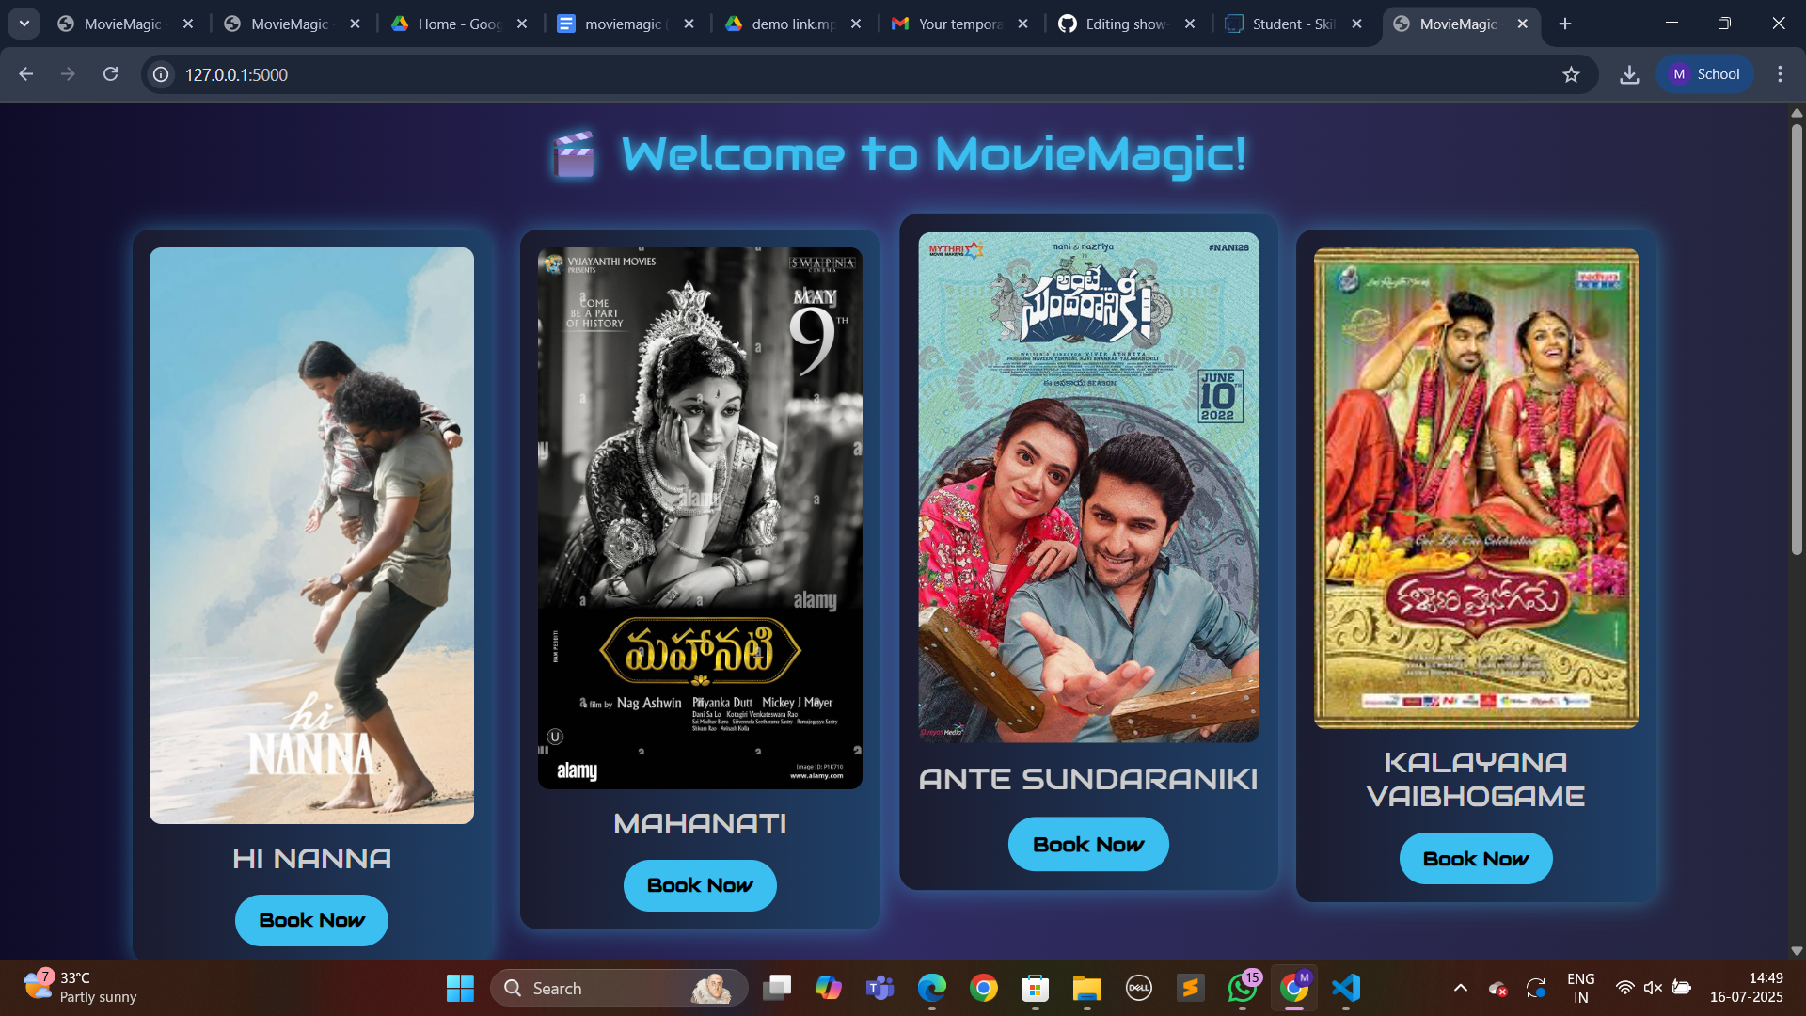



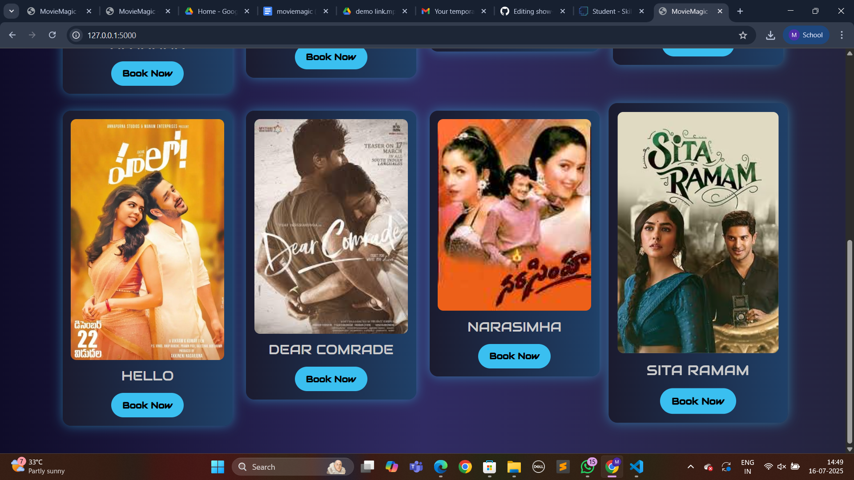

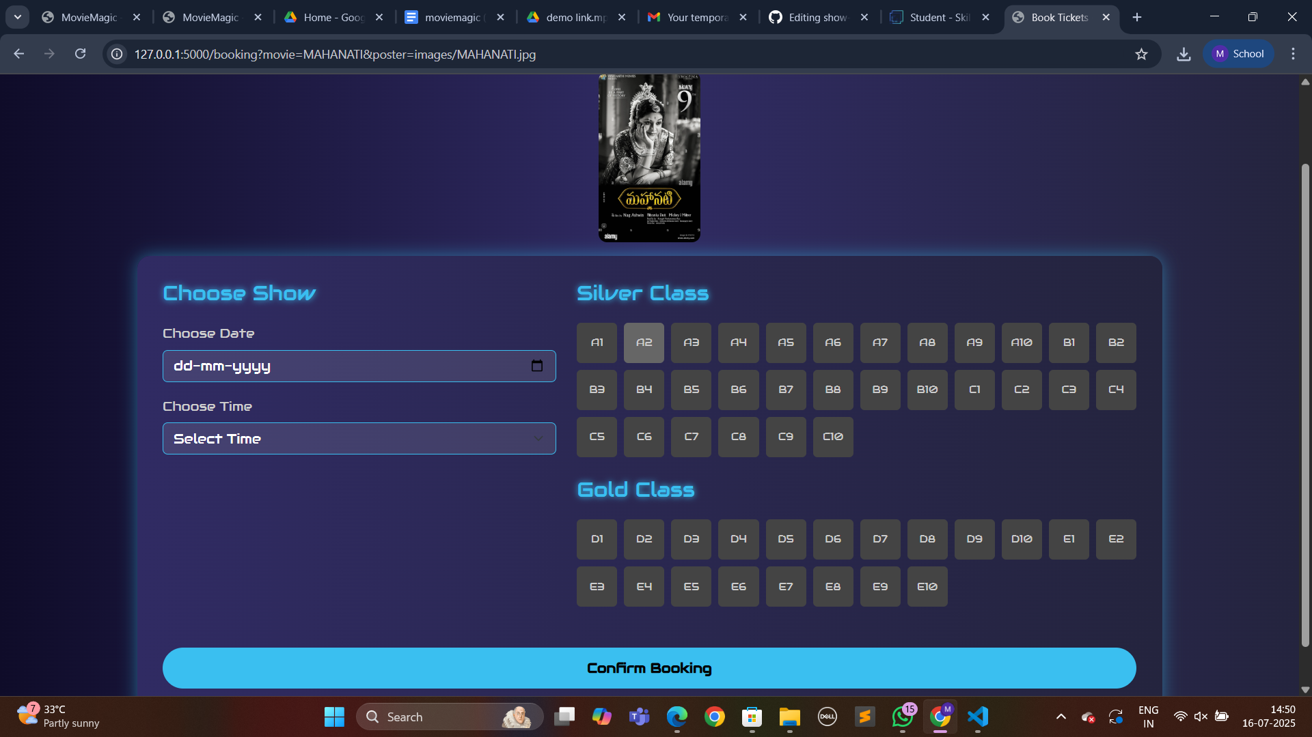

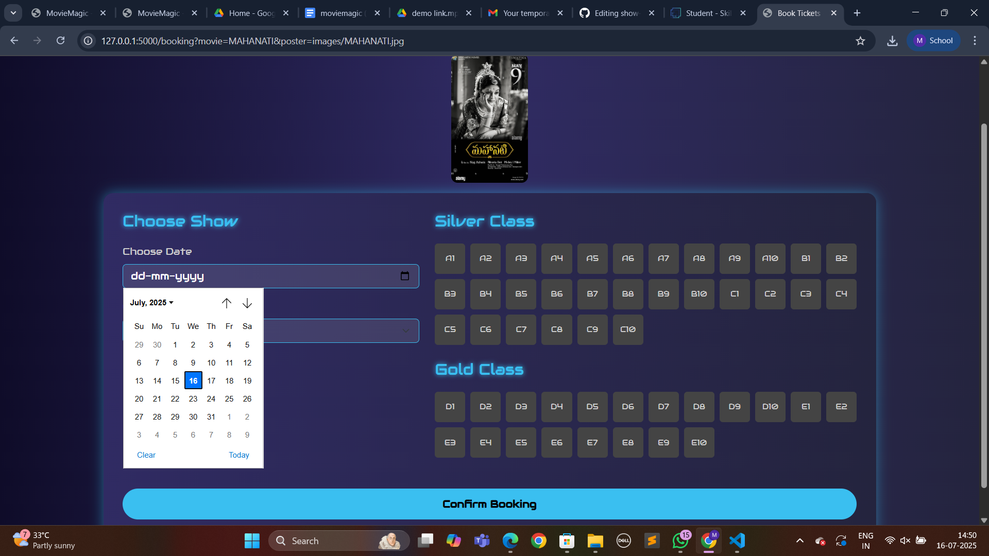

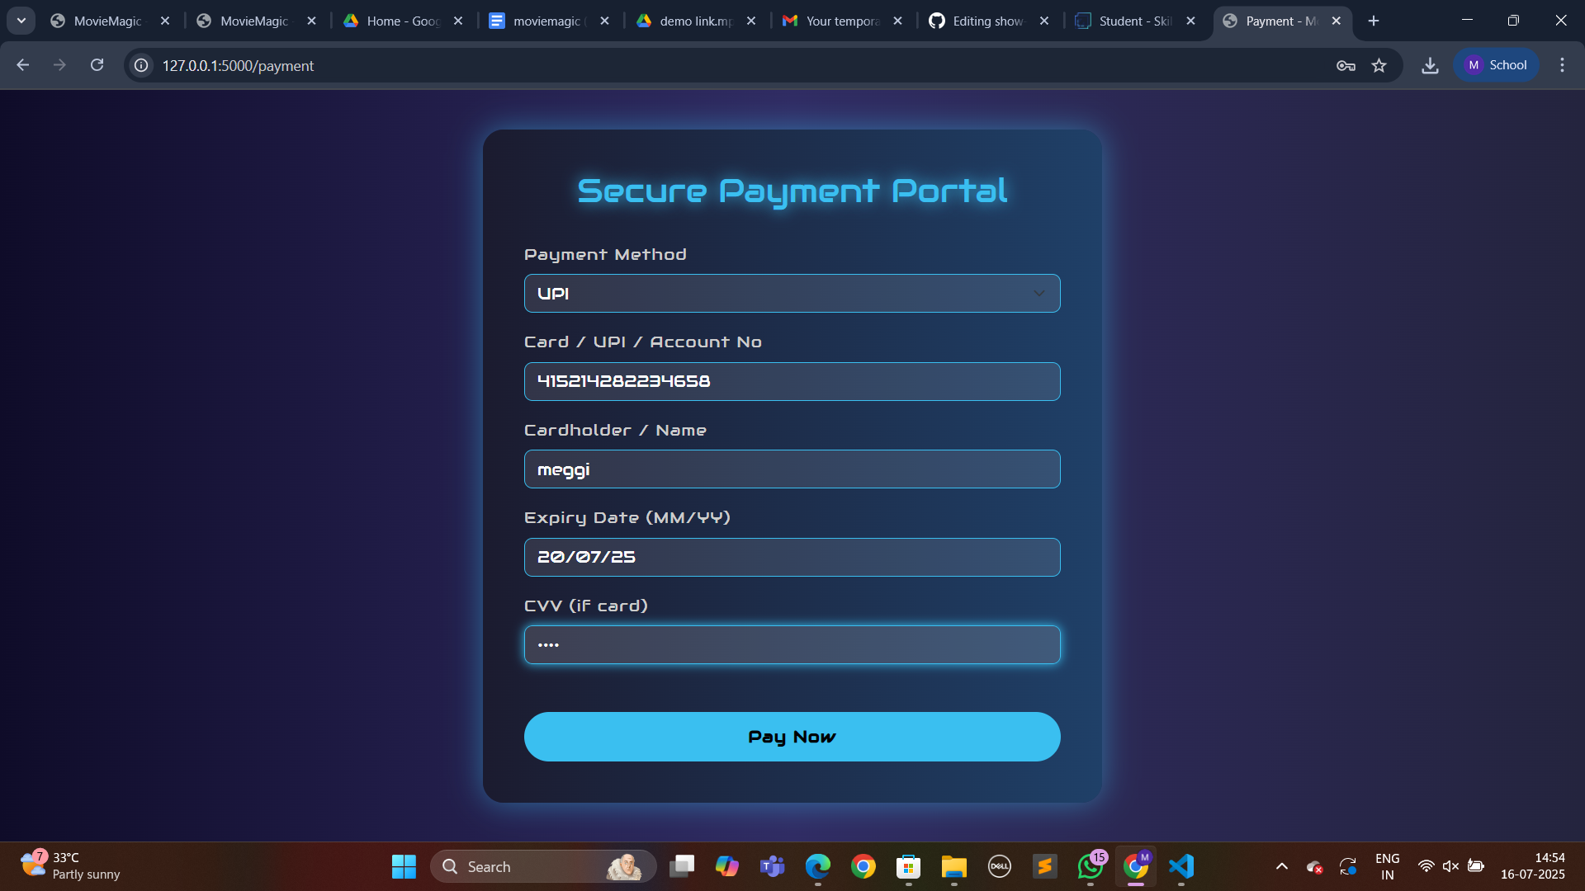

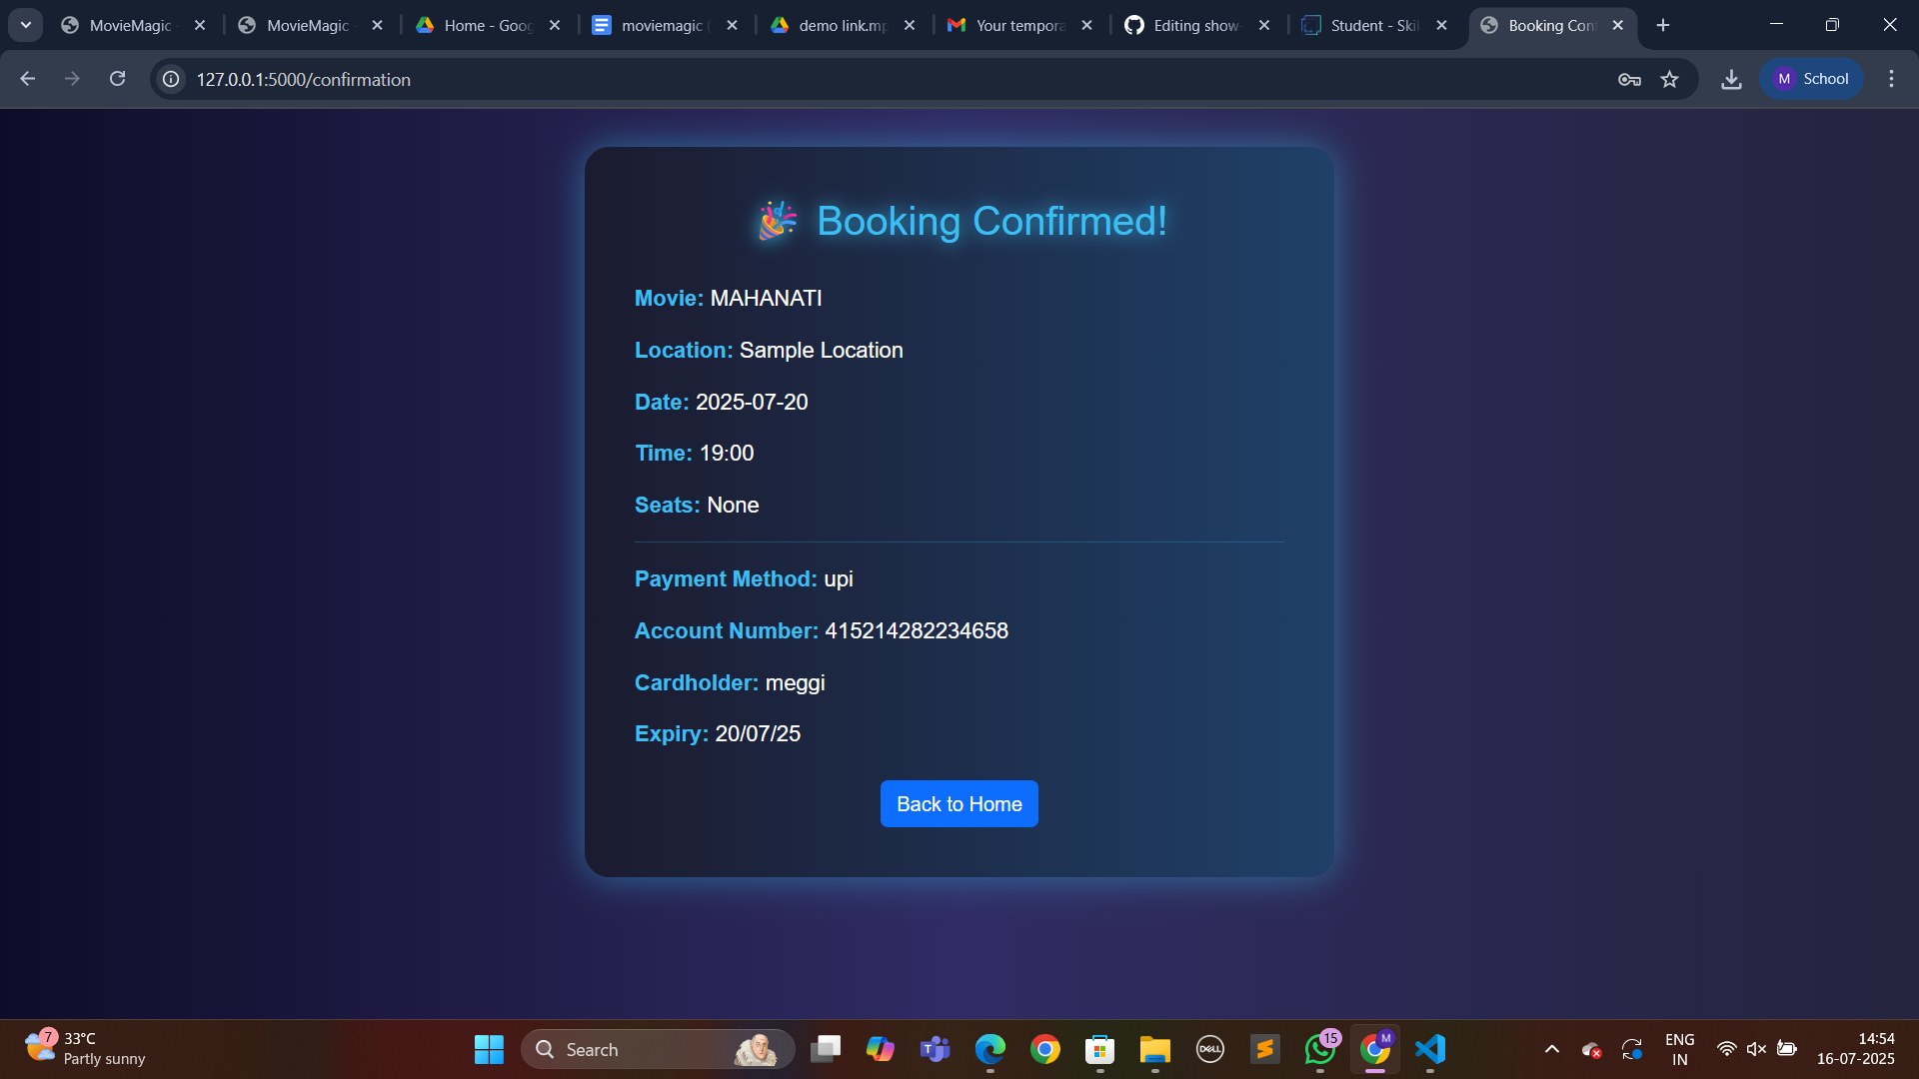

# Conclusion

The Movie Magic website has been successfully developed and deployed using a robust, cloud-native architecture. By leveraging key AWS services such as EC2 for hosting, DynamoDB for real-time data management, and SNS for instant booking confirmations, the platform delivers a scalable and user-friendly movie ticketing experience. This solution addresses the limitations of traditional ticket booking systems by enabling users to seamlessly search for movies, select seats, and receive digital tickets—all from a single platform.

The cloud-based infrastructure ensures that the system can handle a high volume of users and transactions, especially during peak movie release times, without compromising speed or reliability. The integration of Flask with AWS services enables smooth backend operations, including user authentication, movie/event browsing, seat availability checks, and secure ticket booking.

Comprehensive testing has confirmed that all core functionalities—from user registration and login to booking confirmation via email—operate seamlessly. The platform’s modern interface and responsive design further enhance the user experience, making movie booking quick, efficient, and enjoyable.

In conclusion, Movie Magic stands as a powerful demonstration of how cloud technologies can modernize traditional services. It provides an efficient, scalable, and intuitive solution for movie ticket booking, showcasing the potential of full-stack cloud applications in solving real-world user experience challenges in the entertainment industry.

**THANK YOU**